A systematic review of recycling and resource recovery from municipal solid waste for a circular economy to achieve sustainable development goals.

Table of Contents

Abstract 3

1. Introduction 3

2. Materials and Methods 7

3. Results and Discussion 10

3.1. Present scenario of municipal solid waste management (MSWM) at a global level 10

3.1.1. Municipal solid waste generation 10

3.1.2. Composition of municipal solid waste 11

3.1.3. Collection and treatment of municipal solid waste 12

3.2. Recycling practices of MSW 13

3.3. Resource recovery technologies of MSW 14

3.3.1. Thermochemical treatment 15

3.3.2. Hydrothermal treatment 22

3.3.3. Biological treatment 24

3.4. Challenges and recommendations related to the implementation of recycling and resource recovery technologies of municipal solid waste 35

3.4.1. Technological aspect 35

3.4.2. Economic aspect 37

3.4.3. Environmental and climate change 37

3.4.4. Social aspect 38

3.4.5. Policy and regulatory framework 40

3.5. Innovation/recent trend in MSWM 42

3.6. Possible roadmap for the circular economy using recycling and resource recovery technologies of MSW in developed and developing countries 42

3.7. Resource recovery and recycling of MSW towards the achievement of the UN-SDGs 42

4. Conclusion 45

References 46

# Abstract

Municipal solid waste management (MSWM) is a critical issue due to the rapid generation of municipal solid waste (MSW), encompassing socio-economic, environmental, and health challenges, especially in developing countries. MSW is a potential resource for producing energy, nutrients and other value-added materials using thermal, hydrothermal and biological treatment, thereby minimizing greenhouse gas emissions and mitigating climate change. The resource recovery and recycling of waste offers effective management of MSW, contributing to achieving the United Nations Sustainable Development Goals (UN-SDGs) and promoting circular economy (CE). Therefore, the present study aims to systematically review and comprehensively summarize the various waste-to-resource technologies and recycling practices highlighting innovations and their present scenario globally. Moreover, it explains the suitability and effectiveness of each method based on an analytical characteristic of MSW, environmental impact, economic indicators and social acceptance. It was discovered that thermal processes like incineration, gasification, and pyrolysis are more efficient in recovering energy between 544 and 816 kWh per ton of MSW and reducing waste mass by 80-90%. In contrast, biological processes such as anaerobic digestion and composting were found to be more economical and environmentally friendly with higher levels of community acceptance and technology readiness. Furthermore, the challenges associated with their implementation were examined and suggestions were provided for the successful adoption, including revenue generation, public-private partnerships, public awareness and education, stakeholder engagement, and carbon capture and storage technology usage. The study also proposed a possible road map to achieve UN-SDGs and CE, offering valuable insights for policymakers and government authorities to improve MSWM. Overall, this review highlights the significance of the recovery and recycling of MSW, examining the implementation challenges and benefits to attain sustainability and circularity worldwide.

Keywords: Circular economy, Municipal solid waste, Recycling, Sustainable development goals, Sustainable waste management, Waste-to-resources

# Introduction

The rapid increase in the population, urbanization, industrialization, and improved living standards has led to a shortage of resources and a substantial rise in the generation of municipal solid waste (MSW) globally (Fidelis et al., 2023; Ram et al., 2021). Global MSW generation is estimated to increase by approximately 70%, from 2.01 billion tons in 2016 to 3.4 billion tonnes by 2050. Globally, about 67% of total waste generated is properly treated and disposed of through material recovery, recycling, composting, incineration and disposed of in landfills. However, one-third of the waste is still not managed in an environmentally friendly way (Kaza et al., 2018).

The mismanagement of MSW results in a range of environmental pollution such as air pollution due to emissions of greenhouse gas (GHG) and volatile organic compounds (VOCs), soil contamination due to disposal of hazardous elements, and groundwater pollution due to leachate generation (Zhang et al., 2024). (Chen et al., 2020) estimated that GHG emissions will be nearly doubled, increasing from 1323 Mt CO2 eq. in 2015 to 2383 Mt CO2 eq. by 2050, mainly, due to landfills and open dumps. Apart from this, improper treatment and direct disposal of MSW also create a socio-economic impact, affecting the community's well-being, financial status, human and animal health (Zhang et al., 2024). In summary, fast-growing industrialization, human population, and economic development resulted in environmental pollution, natural resource depletion, and global warming (Hoang et al., 2022).

As per the current act and framework, the most preferred approach is to prevent waste generation followed by reuse, recycling, recovery of materials (such as energy, fuel, fertilizer, and other chemicals) and finally controlled disposal (Figure ) (European Council, 2008; US EPA, 2016). European Union (EU) strategies and policies focus on waste reduction through recycling and recovery even though waste prevention is the top priority (Shah et al., 2023). It can not only reduce waste aggregation but also produce energy, valuable materials, fuels for cooking and transportation and chemicals (Nanda & Berruti, 2021). Waste recycling and recovery helps to conserve natural resources, reduce the need for virgin raw materials and minimize air pollution, improving the environment quality and public health. Furthermore, the effective management of MSW through the utilization of recycling and resource recovery technologies minimizes the end-of-pipe treatment and provides the opportunity to achieve a circular economy (CE) (Rezania et al., 2023). Moreover, the implementation of an effective municipal solid waste management (MSWM) system could also achieve UN sustainable development goals (SDGs) (such as SDG 3, 6, 7, 11, 12, 13, 14 and 15) (Nanda & Berruti, 2021; Yong et al., 2021).

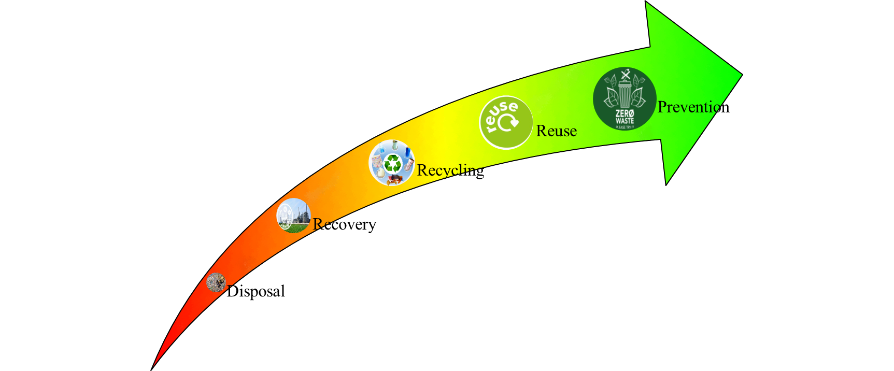

Figure: Priority diagram of waste management ((European Council, 2008)

The resource recovery technologies can be broadly classified as thermal, hydrothermal and biological treatments (Figure ). Processes such as composting, anaerobic digestion, landfilling and incineration are considered conventional treatments whereas pyrolysis, gasification and hydrothermal treatments are nonconventional processes (Munir et al., 2021; Sondh et al., 2022). Some next-generation biological processes are also utilized to generate biofuels (e.g. bioethanol, biodiesel, biohydrogen) (Karmee, 2016; Nanda & Berruti, 2021). The heterogeneous nature of waste, the complexity of process design, higher capital investment, and emissions of air pollutants are major challenges for these technologies (Varjani et al., 2022). On the other hand, in comparison to landfill disposal and open dump, a combination of recycling and resource recovery strategies resulted in extremely favorable environmental performance (Abis et al., 2020). Hence, generally, the selection of the processes for MSWM depends on several factors including waste composition, temporal variation, government law and policies and socioeconomic level (Sondh et al., 2022).

In comparison to developing countries, developed countries implemented waste-to-resource technologies more extensively due to the availability of skilled operators, financial resources, stringent waste disposal and landfilling policies and regulations (Rezania et al., 2023). Recycling practices and resource recovery technologies are still not efficiently implemented in developing nations (Sondh et al., 2022). Even though these technologies have environmental benefits, the need for higher investment, societal acceptance, technological innovations, and usage of recovered resources are major hurdles (Rezania et al., 2023). According to Malinauskaite et al. (2017) the effective MSWM should be environmentally friendly, economically sustainable and socially acceptable for transit towards CE.

This paper aims to explore MSW as a potential source of valuable resources like energy and value-added materials. While, the previous reviewer discussed various municipal solid waste-to-energy technologies, including their advantages and disadvantages (Table ), it did not analyze challenges, innovations and opportunities associated with implementing recycling and resource recovery strategies within the circular economy framework. Moreover, the global development of these strategies and practices over the last decade has not been well explored. A detailed and consistent analysis is still necessary to depict MSW to resource technologies, recycling practices, the challenges and benefits associated with their implementation in the circular economy framework, and recommendations and innovations aimed at sustainable MSWM through recycling and recovery towards the achievement of the UN-SDGs and CE.

The main objectives of this study are to analyze available recycling practices and waste-to-resource technologies, while also identifying the current status of these strategies around the world. Extensive work has been conducted focusing on both developed and developing nations, with an effective comparison of present MSWM practices across different income-level countries being examined. To address notable gaps in previous reviews, the study specifically provides recommendations, opportunities and innovations to overcome the challenges associated with the effective implementation of recovery and recycling practices. Additionally, this review proposes a roadmap for sustainable MSWM through the concept of CE, providing insights into opportunities for enhancing current MSWM systems in both developed and developing countries. Finally,

As a result, it aims to answer the following research questions are as:

1. What is the present scenario of MSWM at a global level?
2. What are the most common and effective recycling and resource recovery strategies from MSW?
3. What are the challenges and recommendations (technological, economic, social, environmental, policy and regulatory) in implementing recycling and resource recovery strategies in developed and developing countries?
4. What are the innovations (such as technological, process, social, policy and regulatory innovations) in MSWM?
5. What is the possible framework for an achievement of circular economy and UN-SDGs using recycling and resource recovery technologies of MSW in developed and developing countries?

# Materials and Methods

A systematic literature review was conducted to provide a current municipal solid waste management scenario focusing on resource recovery and recycling, examining challenges and opportunities around the globe. A PRISMA (Preferred Reporting Items for Systematic Reviews and Meta-Analyses) was used to gather informative and relevant literature from two scientific databases ‘Web of Science (WoS)’ and ‘SCOPUS’ using boolean operators and truncation. The studies were also identified via other sources such as websites and organizations. The search string was utilized based on the topic encompassing title, abstract, and author keywords. The details of different eligibility criteria for the inclusion and exclusion of articles are presented in Table .

A review process followed five steps as demonstrated in Figure. In the first step, the total number of articles was identified using a combination of different keywords. After applying inclusion and exclusion criteria, the initial search discovered 654 articles from both databases. In the second step, duplicates were removed, and the articles were screened by reviewing their title, abstracts and author keywords. Subsequently, in the next step, all the retrieved articles were thoroughly read to determine relevant studies. In the fourth step, the snowballing technique was applied to confirm adequate coverage of selected studies by scanning the references of the identified articles from the previous step. Additionally, the reports from websites and organizations were screened using the same process. Finally, 106 articles and reports were gathered for qualitative analysis for this study.

Table: Details of the search criteria

|  |  |  |
| --- | --- | --- |
| **Criteria** | | **Description** |
| Database | | Web of Science and SCOPUS |
| Search string | Municipal solid waste | "municipal solid waste" OR "household waste" |
| Technologies/management | "resource recovery" OR "energy recovery" OR "material recovery" OR "municipal solid waste recycling*" OR "municipal solid waste to energy*" OR "municipal solid waste to value*" OR "municipal solid waste to material" OR "municipal solid waste strategy*" OR "municipal solid waste technique" OR "municipal solid waste technology" OR "municipal solid waste practic*" OR "municipal solid waste management" OR "municipal solid waste polic*" |
| Circular economy | "circular economy" OR "circularity" |
| Search with | | Article title, abstract, and author keywords |
| Year | | Up to 2024 |
| Date of running | | 31st May 2024 |
| Inclusion criteria | | Peer-reviewed journal and review articles in English |
| Exclusion criteria | | Conference papers, book chapters, conference review, notes, non-english articles |

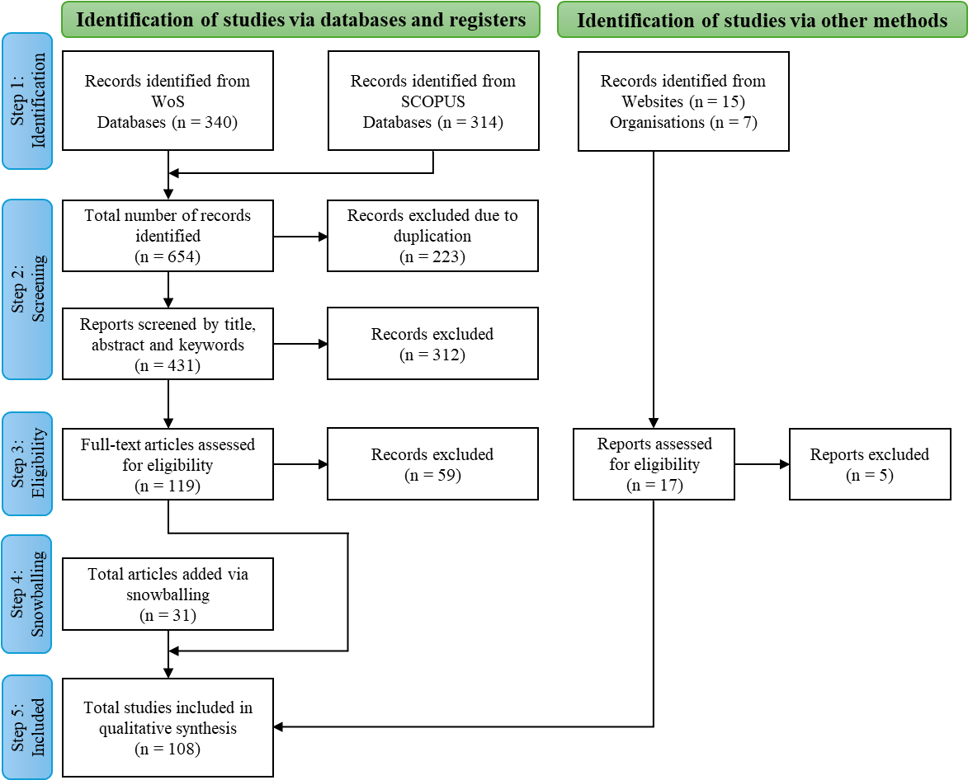

Figure: Steps of the literature search based on the PRISMA method

# Results and Discussion

## Present scenario of municipal solid waste management (MSWM) at a global level

This section presents a summary of the total MSW generation, source, composition and current management practices of MSW at a global level. According to the World Bank Report (Kaza et al., 2018), MSW generation, collection and treatment strongly correlate with economic development. The World Bank categorized the global economy into four groups, (1) high income (e.g. Australia, Japan, USA and many European countries) (2) upper-middle income (e.g. Brazil, China, and South Africa) (3) lower-middle income (e.g. Bangladesh, India and Indonesia) (4) Low income (e.g. Afghanistan, Ethiopia and Nepal). Thus, this section also provides the current scenario of MSWM based on an economic level. This provides the overall information for understanding the present scenario of resource recovery technologies and the suitability of the technologies based on the composition of waste and financial status of the country in the following section 3.2.

### Municipal solid waste generation

Globally, MSW generation was estimated at around 2.1 billion tons per year, averaging 1.02 kg/day/capita in 2020 based on the latest data by the World Bank Group (What A Waste Global Database, 2021). It is estimated to increase to 2.68 and 3.78 billion tons by 2030 and 2050, respectively (United Nations Environment Programme, 2024). Figure demonstrates a positive correlation between waste generation and income level. However, for the upper-middle income level, the waste generation is slightly (marginal) higher than the high income level. This is plausible because top contributors to global waste generation, such as China and Brazil fall into the upper-middle income group. Whereas lower-middle income and lower income households generated significantly lower amounts of waste, approximately 22% or 458 million tons and 5% or 95 million tons of the overall waste, respectively. In addition, waste generation per capita also increases with income level (Figure ). High income countries generate more waste per capita (1.68 kg/day) due to the highest urbanized rate. On the other hand, upper-middle, lower-middle, and lower income countries generate significantly lower waste per capita, 0.83, 0.59 and 0.44 kg/day, respectively (What A Waste Global Database, 2021).

Figure: MSW generation

### Composition of municipal solid waste

MSW contains several organic and inorganic compounds based on their sources such as residential, industries, markets and shops, schools, commercial buildings, etc (Hoang et al., 2022). MSW can be classified into eight main groups namely, food, paper and cardboard, plastic, glass, metal, rubber and leather, wood, and yard and garden waste. The remainder is categorized into others (Kaza et al., 2018). Globally, the largest proportion of waste is food waste (42%) followed by paper and cardboard (15%), plastic (12%) and yard and garden waste (11%) (Figure ). The remaining waste (glass, metal, wood, rubber and leather) accounts for approximately 16%. Figure demonstrates MSW composition significantly varied by income level. The percentage of food waste decreases with a rise in income levels, while the percentage of plastic, paper and cardboard increases. Compared to lower income countries, higher income countries consume goods which include paper and plastic packing because of the higher urbanization rate and their high standard of living (Kaza et al., 2018; United Nations Environment Programme, 2024). Furthermore, lower-middle and lower economy countries are mainly developing countries which contain greater than 50% of the organic fraction of MSW.

Figure: MSW composition

### Collection and treatment of municipal solid waste

The figure demonstrates MSW collection and treatment rates through various methods such as recycling, composting, incineration, landfilling, open dump, and other advanced treatment technologies. The MSW collection rate is strongly correlated with income level. The highest MSW collection rate of approximately 97% was in high-income countries followed by upper-middle (84%), lower-middle (60%) and lower income countries (47%) in 2020 (What A Waste Global Database, 2021). MSW management practices significantly vary by the economic status of the country. High economic countries such as Germany, Denmark, Sweden, USA, and Japan use mainly resource recovery through recycling, incineration and composting. In high income countries, 29% of MSW is recycled whereas in other countries between 4 and 6% of MSW is recycled (Figure ). Moreover, high and upper-middle income countries managed 22% and 10% of their MSW via incineration, respectively. In contrast, lower-middle and lower income countries openly dumped 66% and 93% of MSW, respectively (Kaza et al., 2018).

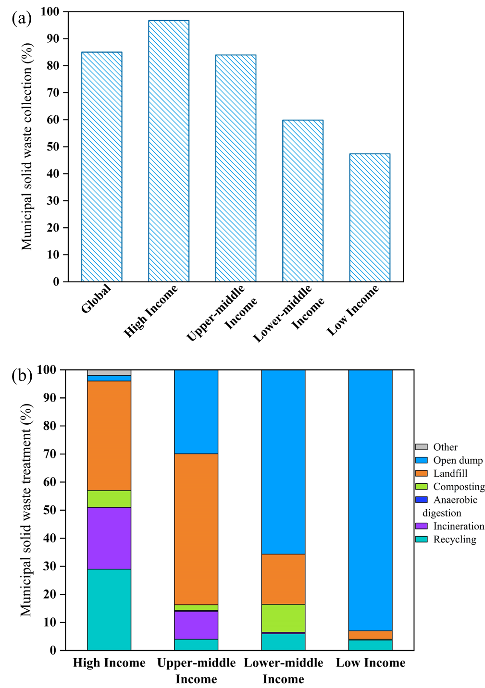

Figure: MSW (a) collection (b) treatment

## Recycling practices of MSW

Recycling of MSW is on a higher level than resource recovery in a priority diagram for a sustainable waste management system and transition toward CE (Abis et al., 2020). It involves mainly four steps, (1) collection and segregation, (2) cleaning, shredding and reprocessing of waste, (3) manufacturing of new material or product (4) marketing and distribution. Recycling processes depend on several parameters such as waste composition, energy consumption and economic status (Durak, 2023). However, recycling of MSW is primarily limited to paper, plastic, glass and metals (Gutiérrez et al., 2021). Globally, there are three types of recycling value chains. The first is formal recycling which is mainly managed by local authorities, municipalities or private waste management companies and is commonly found in high income countries e.g. European countries, Japan and the USA. Another is informal recycling which is predominant in many Asian and African countries like China, Indonesia, Kenya and South Africa, where waste pickers collect recyclable material from open dumpsites and storage facilities. Lastly, hybrid recycling is run between the formal and informal sectors and prevails in upper-middle and lower-middle income countries such as Brazil, Colombia, India and Bangladesh (Silva de Souza Lima Cano et al., 2022).

Recycling conserves natural resources and protects the environment by reducing pollutant emissions, minimizing GHG emissions and mitigating climate change. Moreover, it generates revenue and minimizes energy consumption costs of resource recovery technologies of MSW (Prajapati et al., 2021; Sondh et al., 2022). Yaman et al. (2020) calculated the total energy savings from recycling through a material recovery facility (MRF) technology and found a reduction in GHG emissions of -1.122 tons CO2-eq per ton of MSW. On the downside, it demands skilled labor, technological innovations, and financial resources (Siddiqi et al., 2020). Globally, about 19% of MSW being recycled in 2020 (What A Waste Global Database, 2021). In 2022, the EU recycled 68 million tons of MSW, achieving a recycling rate of 48.6%. Germany led with a recycling rate of approximately 69%, followed by Austria, the Netherlands, Luxemburg, and Belgium at around 63%, 62% and 58% respectively (Eurostat, 2024). Australia and New Zealand, along with North America recycled around 53% and 38% of total MSW, respectively. Whereas South American, Asia and African countries still have relatively low recycling rates, ranging between 5 and 10% (United Nations Environment Programme, 2024).

## Resource recovery technologies of MSW

The resources (energy and material) can be recovered from MSW using thermal (e.g. incineration, gasification, pyrolysis), hydrothermal (e.g. hydrothermal liquefaction and hydrothermal carbonization), biological (e.g. anaerobic digestion, composting, biological conversion into bioethanol, biodiesel, biohydrogen, bio-electrochemical treatment, landfilling) and hybrid treatment (combination of the thermal, hydrothermal or biological process). Figure demonstrates the various technological options, and their products obtained.s

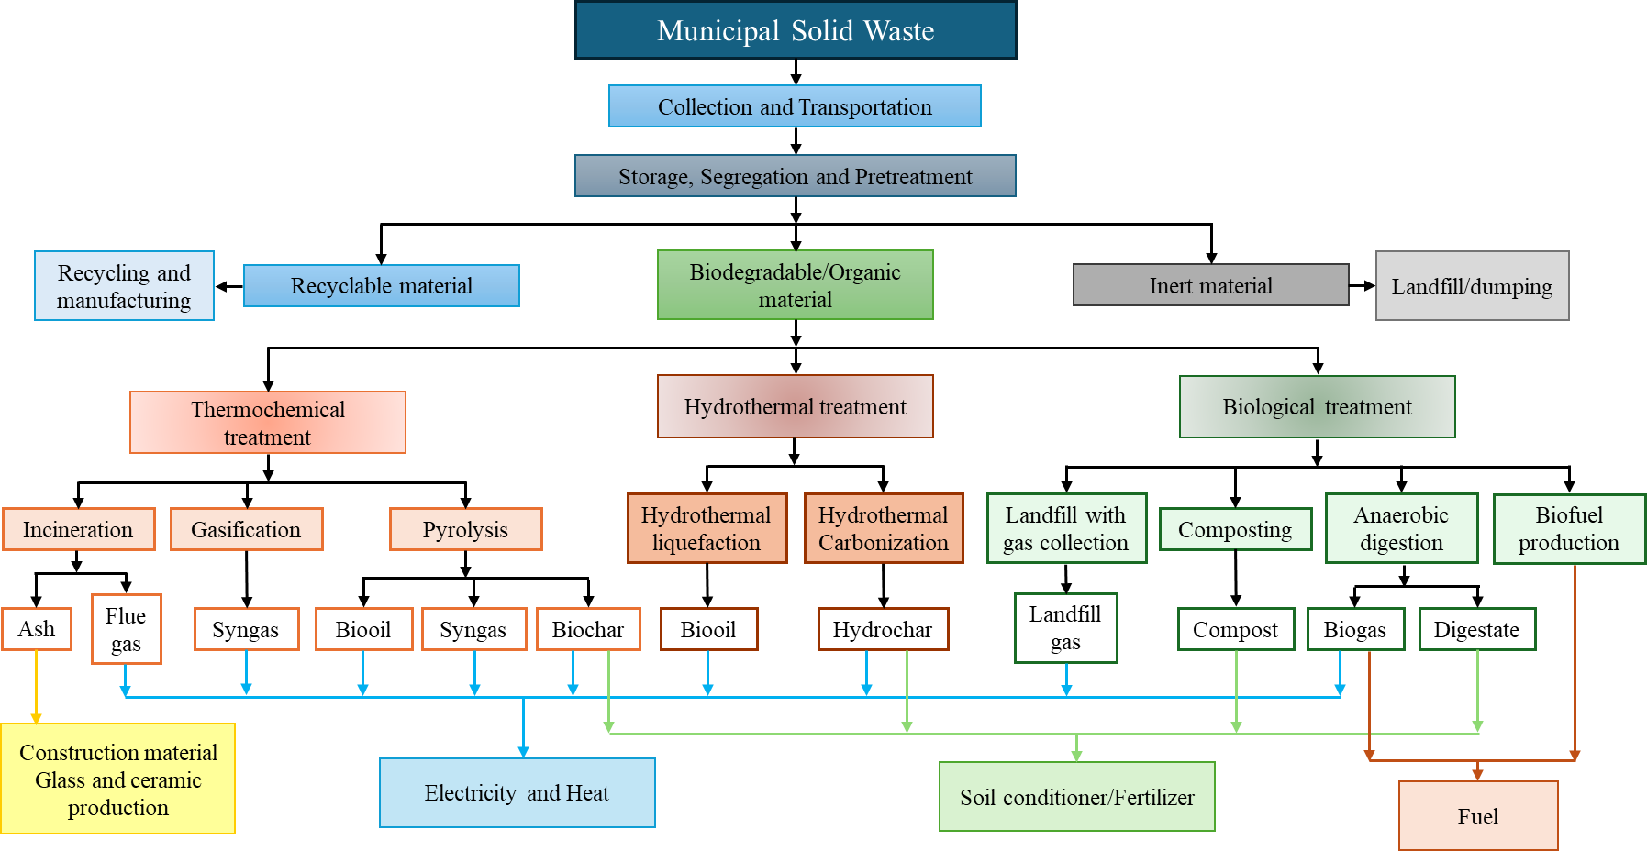

Figure: Technological options for resource recovery from MSW

### Thermochemical treatment

#### Incineration

Incineration is a thermal treatment of MSW to recover energy and value-added products like ash from MSW by combusting or burning the waste at very high temperatures between 800 and 1200 °C in the presence of oxygen (Nanda & Berruti, 2021). It generates two types of ash (such as fly ash and bottom ash), which have potential use in construction materials (e.g. cement, concrete, brick, and road pavements), glass and ceramic production, agricultural applications, adsorbents, and zeolite production (Barracco et al., 2023; Ram et al., 2021). The recovered heat can be utilized to drive the turbine to produce electricity (Materazzi & Foscolo, 2019). The efficiency of the process depends on the analytical characteristics of MSW mainly, waste composition, moisture content, calorific value, bulk density, etc. and operating parameters such as temperature, airflow and gas residence time (Munir et al., 2021; Nanda & Berruti, 2021). The high moisture content, low calorific value and organic matter in MSW can significantly impact incinerator performance and combustibility, leading to reduce energy recovery (Nanda & Berruti, 2021). The International Energy Agency (IEA) stated that for effective energy generation MSW should have 8 – 12 MJ/kg of calorific value per ton of MSW and can produce around 600 kWh of energy (Patel, 2003).

The process produces 180 kg of residues and 544 kWh of energy per ton of MSW, resulting in a 70 - 80% reduction in waste mass at optimum reaction conditions (Ramos et al., 2019; Young, 2010). In contrast, it emits harmful pollutants such as particulate matter (PM), dioxins, heavy metals, volatile organic carbons (VOC), CO2, SOx, NOx and other gases which can create air pollution and affect human health (Chen et al., 2020; Munir et al., 2021). Also, ash produced during the process contains significant amount of minerals and heavy metals such as Ni, Zn, Cu, Cd, Pb, As, etc. (Van Caneghem et al., 2019). Therefore, research is currently being developed on the treatment and application of incineration ash. The best management practices are recovery of value-added material and heavy metals, recycling to construction material and reuse for the manufacture of ceramics (Abis et al., 2020). Figure demonstrates a schematic flow diagram of MSW incineration process with resources recovered, their use, and the environmental and socio-economic impact of the process.

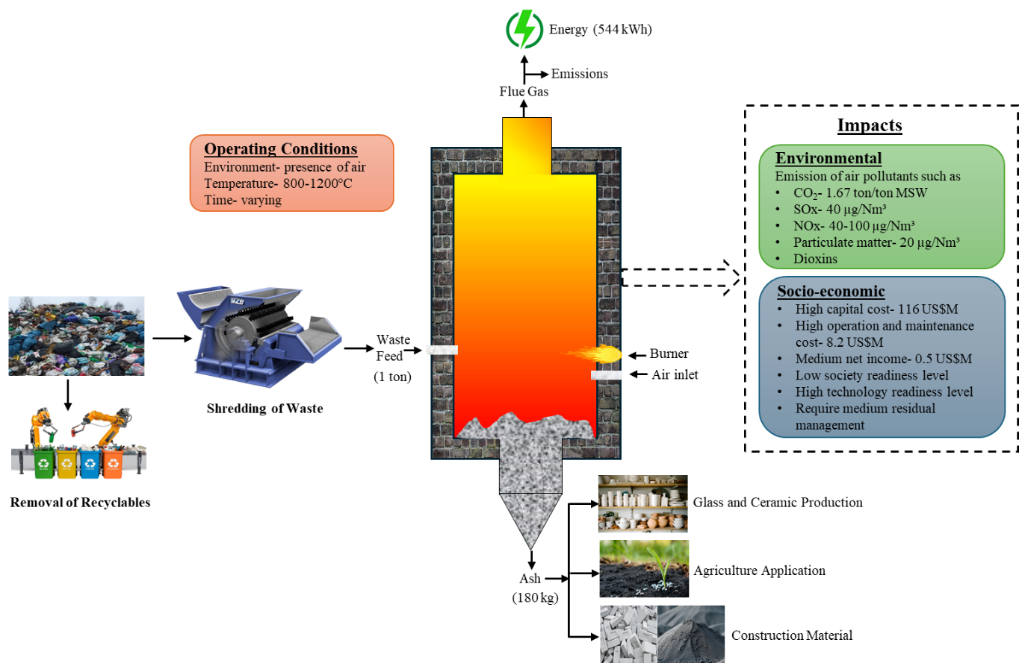

Figure: MSW incineration process (Munir et al., 2021)

In developed countries, incineration is the key option for managing MSW compared to biological due to the high calorific value of the MSW, availability of skilled operators, financial resources, lack of land availability, stringent waste disposal and landfilling policies and regulation (Psomopoulos et al., 2009; Yaman et al., 2020). Incineration with energy recovery plants is operating in the USA, Europe and Japan. Globally, Japan has the highest incineration rate, treating 80% of its waste through the incineration process (What A Waste Global Database, 2021). Many European countries such as Denmark, Sweden, Norway, Italy, Greece, etc. use the incineration process to manage MSW (Lu et al., 2017; Malinauskaite et al., 2017). In 2020, a total 504 incineration plants were discovered in Europe out of which France has the most 124 plants, followed by Germany (100 plants), Italy (37 plants), Sweden (36 plants) and Denmark (26 plants) (Shah et al., 2023). Globally, 21436 MW capacity of MSW energy plants were installed from 2010 to 2023. USA, Germany, and Japan are the major contributing countries with plant capacities of 1025 MW, 1023 MW, and 1021 MW, respectively. (Renewable Energy Agency, 2024). Germany achieved the highest energy recovery of 7.1 MWh/ton, followed by Sweden which produced 3.1 MWh/ton of MSW (Shah et al., 2023; Sweden Waste Management 2022, 2022). Sweden imports waste from the neighboring country mainly Norway for the incineration process to generate electricity, heat and value-added materials (Malinauskaite et al., 2017). However, it emits air pollutants such as dioxins, VOC and heavy metals in the ash, causing serious environmental impact. To address this, Sweden implemented a tax on incineration plants in 2020, which led to reduced emissions and advancements in gas-cleaning technologies (Rylander & Lagerkvist, 2024).

In developing countries, incineration is not feasible due to unfavorable waste composition and characteristics, lack of source segregation of MSW, limited financial resources and technical expertise, and available cheap land for direct disposal (Kumar & Samadder, 2017). However, the advancement of technologies and reducing treatment costs increase the viability of the process in urban areas of developing countries (Siddiqi et al., 2020). In recent years, this process has gained interest in many developing nations in Asia and Africa to meet regional energy demands (Hoang & Fogarassy, 2020; Zhang et al., 2024). In China, the capacity of MSW to energy incineration plants has grown significantly over the years. According to the International Renewable Energy Agency (IRENA), in 2014, capacity was 1893 MW, which increased to 12885 MW by 2023 (IRENA, 2024). However, the conversion rate of MSW to energy is less compared to other developed countries due to the unsegregated and high moisture content of waste (Awasthi et al., 2022). The incineration plants have failed in India due to moisture-rich waste with low calorific value, which has resulted in no operational incineration plants in the country (Thomas & Soren, 2020).

Incineration emits 1100 kg of CO2 per ton of MSW incinerated to produce energy (Patel, 2003). Therefore, the European Union (EU) has implemented stringent operating conditions and technical requirements requiring the inclusion of pollutant capture and treatment systems (European Council, 2010). To address this, recent advancements focus on modern incineration with carbon capture and storage (CCS) systems that meet environmental protection standards (Dal Pozzo et al., 2023). However, (Lausselet et al., 2017) conducted a life cycle assessment (LCA) to identify the environmental impact of CCS in Norway and found that it has a negative impact on freshwater. Currently, four modern incineration plants operate worldwide in Japan, Norway and the Netherlands (Wienchol et al., 2020). The incineration plants in Norway and the Netherlands process more than 400,000 and 830,000 tons of MSW annually, respectively. In 2019, they were expected to capture 400,000 and 100,000 tons of CO2/year by 2021. The facility in Japan has a carbon-capturing capacity of 10 tons/day, with the captured CO2 being used in agricultural applications (Kearns, 2019).

#### Pyrolysis

Pyrolysis is another thermochemical treatment that produces bio-oil, biochar and syngas from MSW. The process takes place at temperatures of 300 to 1200 °C in the absence of oxygen (Andooz et al., 2023). The pyrolysis process of MSW is illustrated in figure. It also represents operating conditions, recovery of resources and their applications. The pyrolysis can be categorized as slow, fast, flash, vacuum, plasma, catalytic, and microwave pyrolysis based on the operating conditions such as heating rate and source, and vapor residence time (Andooz et al., 2023). The yield and quality of the resources depend on several operating parameters such as feedstock characteristics, temperature, residence time, and heating rate (Nandhini et al., 2022). Moreover, the process also recovers pyro-oils, wax, and tar based on reaction conditions (Hoang et al., 2022; Tripathi et al., 2016). Flash pyrolysis can produce a higher percentage of oil whereas slow and flash pyrolysis can recover a higher proportion of char and syngas (Dabe et al., 2019). The produced syngas is the mixture of several combustible compounds such as carbon monoxide (CO), hydrogen (H2), carbon dioxide (CO2), methane (CH4) and other volatile organic compounds (VOCs) having a net calorific value of 10 to 20 MJ/Nm3 (Dabe et al., 2019). Pyrolysis of MSW generates 571 kWh of energy with a power generation capacity of 5.5 MW per ton of MSW by reducing waste mass by 84% (Munir et al., 2019; Young, 2010). Pyrolysis is more environmentally friendly because it releases lower amounts of air pollutants and greenhouse gases as compared to the incineration process (Gutiérrez et al., 2021). Additionally, it also operates at lower temperatures between 300 and 850 °C (Dabe et al., 2019). However, the process releases 5.7 µg/ Nm3 of particulate matter, 35 µg/ Nm3 of SOx and 77-139 µg/m3 of NOx (Munir et al., 2019).

Pyrolysis has gained considerable attention in many developed countries including Europe, Japan, Australia and Indonesia for MSW to resource recovery. In contrast, the process is still under the trial or implementation stage in developing countries. However, this process has not achieved the same commercial success worldwide as the gasification process due to high capital (87 million USD), maintenance and operation costs (7.2 million USD/year) with a lower net annual revenue of 0.5 million USD (Gutiérrez et al., 2021; Young, 2010). In Europe around 50 to 100 large to small-scale plants have been installed. Germany has a higher capacity of plants around 1,150,000 tons per year, followed by Denmark and the Netherlands with capacities of 15,000 and 10,000 tons per year, respectively. Sweden, Italy, France, and Finland have small-scale plants with capacities of 3,000 to 6,000 tons per year (Shah et al., 2023). Since 2000, Japan has been operating 6 pyrolysis plants, each with a capacity to treat MSW between 50000 and 108000 tons per year (Panepinto et al., 2015). According to the Australian Renewable Energy Agency (ARENA), annually, Australia managed around 4,000 tons of MSW through pyrolysis. India has a small-scale plant with a capacity of 10 and 5 tons of MSW per day in various states including Tamil Nadu, Maharashtra, Andhra Pradesh, Rajasthan, Uttar Pradesh and Bihar (M. Singh et al., 2024).

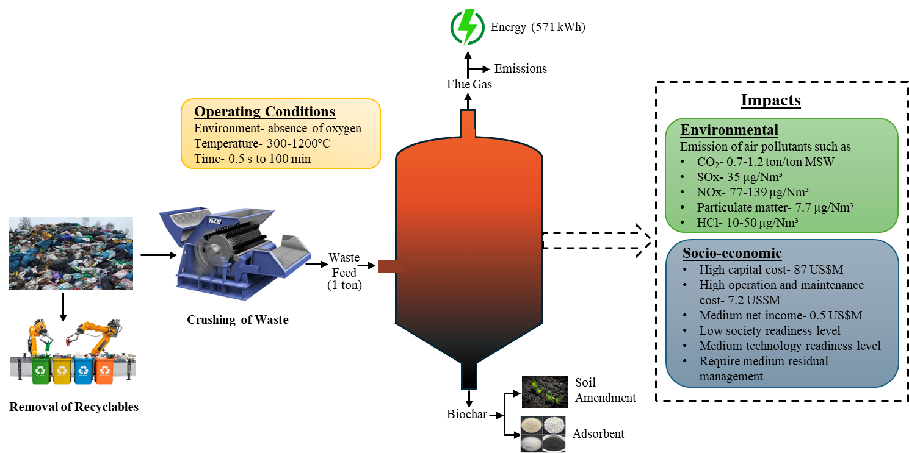

Figure: MSW pyrolysis process (Munir et al., 2019; Young, 2010)

#### Gasification

Gasification is a thermochemical process that converts MSW into heat and syngas in a controlled supply of oxygen, air, or both at high temperatures (700-1100 °C) (Hameed et al., 2021; Young, 2010). The resulting syngas is a composition of carbon monoxide (CO), hydrogen (H2) and a smaller proportion of methane (CH4) with a calorific value between 4 and 50 MJ/Nm3. It is primarily produced due to the decomposition of the organic fraction of MSW (OFMSW). However, it also contains impurities such as tar, particulates, HCl, alkaline and sulfur compounds (Chan et al., 2019). Syngas can be utilized in gas turbines and internal combustion engines for power generation, yielding around 685 kWh of energy per ton of MSW (A. T. Hoang et al., 2022; Young, 2010). The efficiency and performance of the process are influenced by several operating parameters such as oxygen or air supply, reaction temperature, residence time and feedstock characteristics (Nandhini et al., 2022). This process generates more energy than incineration and pyrolysis, while reducing the weight of MSW by 80 to 90 % (Munir et al., 2021). Moreover, it has lower capital, operation and maintenance costs than pyrolysis and incineration, with a net annual revenue of 3.1 million USD (Young, 2010). On the other hand, major limitations of the process are the need for purification of syngas and the generation of tar, ash, particulate matter and heavy metals which can agglomerate in the gasifier and pose environmental hazards (Hoang et al., 2022; Munir et al., 2021). A schematic diagram of the gasification of MSW is demonstrated in figure, highlighting operating conditions, material and energy recovery with their applications, and the environmental and socio-economic impact of the process.

The gasification process for resource recovery from MSW is limitedly used only in developed countries including Denmark, Germany, Sweden, Finland, the Netherlands, Japan, UK and the USA (Panepinto et al., 2015; Shah et al., 2023). Japan is the leading country in the gasification process, with 85 small- to large operational plants with an average capacity of 200 tons/day. Germany has a gasification plant with a capacity of 250000 tons of MSW per year, which has been in operation since 2001 (Panepinto et al., 2015). In developing, nations implementation of the process faces technical and socio-economic challenges (Thomas & Soren, 2020). India operates two gasification plants to handle agriculture and forest waste (M. Singh et al., 2024).

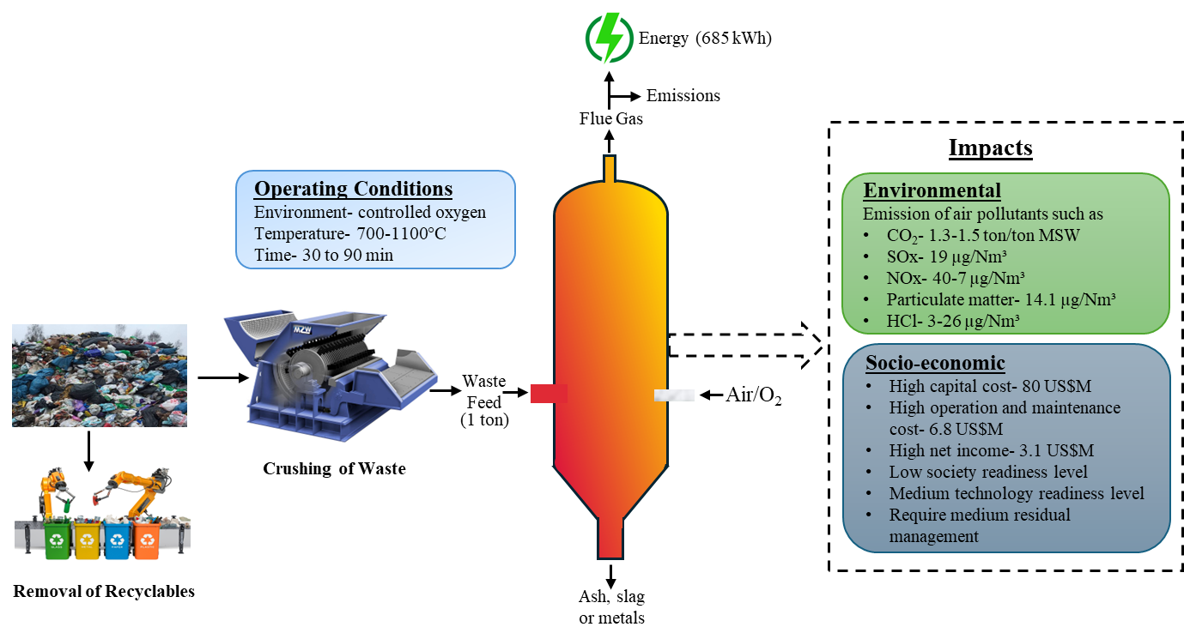

Figure: MSW gasification process (Munir et al., 2019; Young, 2010)

The recent development of plasma gasification for MSW can overcome the limitations of conventional gasification by producing relatively clean syngas, minimizing tar production and recovering high energy of around 816 kWh/ton of MSW (Munir et al., 2019; Young, 2010). The process can take place at extremely high temperatures in the range of 2000 to 14000 °C in four stages namely, removal of moisture from MSW i.e. drying, removal of volatile from MSW and recovery of char i.e., devolatilization, combustion in the presence of oxygen to produce energy and generation of syngas through the reduction process (Munir et al., 2019). Nandhini et al. (2022) stated that plasma gasification is the most suitable method for MSWM. However, Afrane et al. (2022) discovered that it is the least suitable method in developing countries due to moisture-rich MSW. Despite several advantages over conventional processes, the process is still limited to lab-scale may be due to high investment costs, and lower societal acceptance even in developed nations (Ramos & Rouboa, 2022). Only five plants worldwide operate in Japan and China for MSW to resource recovery (Fabry et al., 2013; Munir et al., 2019). Due to low societal readiness and safety concerns process has not been successful in North America and Europe (Munir et al., 2019).

### Hydrothermal treatment

#### Hydrothermal liquefaction

Hydrothermal liquefaction (HTL) is a hydrothermal process that operates at a lower temperature (250-375 °C) than other thermal processes but at high pressure between 10 and 25 MPa and uses water as a solvent (figure ). The process converts MSW to high-energy liquids and recovers bio-oil (Tews & Garcia-Perez, 2022). It also produces a small fraction of gas and carbon-rich solids as biochar. The feedstock characteristics and several reaction conditions such as reaction time, temperature, and pressure affect the yield and quality of bio-oil (Durak, 2023). The maximum yield of bio-oil obtained at residence time (50-90 min), temperature (330-350 °C), and pressure (10-15 MPa) (Varjani et al., 2022).

Compared to other thermal processes, the main benefit of hydrothermal liquefaction is that it can be useful for the decomposition of moisture-rich MSW as drying is not necessary, significantly reducing the pretreatment costs. Moreover, the process requires low investment and operating costs (Nanda & Berruti, 2021). However, hydrothermal liquefaction has a low adoption rate and very few lab-scale studies are available on resource recovery from MSW likely due to low societal and technological readiness as well as lack of awareness and need for safety precautions as it operates at very high pressure (Hoang et al., 2022; Nanda & Berruti, 2021).

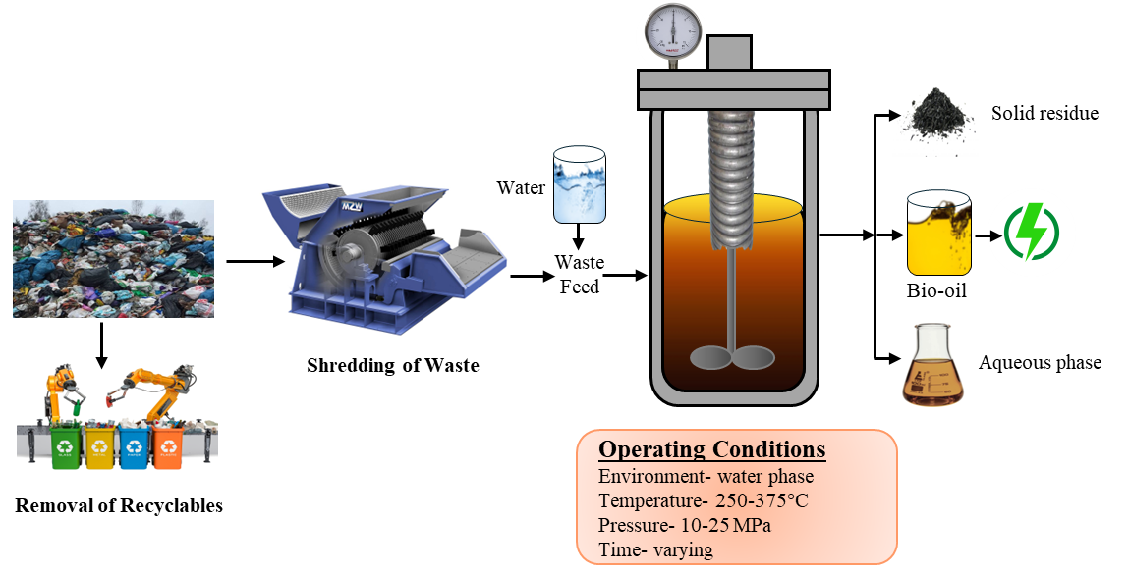

Figure: Resource recovery through hydrothermal liquefaction process (Durak, 2023)

#### Hydrothermal carbonization

Hydrothermal carbonization is the same as hydrothermal liquefaction which performs at a comparatively lower temperature between 180 and 250 °C and pressure in the range of 1 to 4 MPa. The process takes place in a sequence of chemical reactions including hydrolysis, dehydration, decarboxylation and polymerization which converts organic compounds to carbon compounds into two phases namely solid phase (such as hydrochar or biochar) and liquid phase (process wastewater) in the presence of water (Awasthi et al., 2022; Durak, 2023). The process wastewater can be treated via biological processes such as anaerobic digestion, producing biogas and fertilizer. Hydrochar is rich in carbon which can be utilized as a soil amendment, solid fuel, or adsorbent (Babu et al., 2021). The process performance, efficiency and yield of the product rely on MSW characteristics and various operating conditions including temperature, residence time and pressure (Durak, 2023). Figure demonstrates a schematic flow diagram of the hydrothermal carbonization process.

Hydrothermal carbonization has several benefits including lower residence time, low capital costs and a smaller area for the equipment (Babu et al., 2021). Additionally, the process can handle wet waste without pretreatment such as drying and reduces MSW mass by 90-95% which decreases the overall operating cost (Durak, 2023; Hoang et al., 2022). On the downside, this technology has also not gained commercial attention plausibly due to lower societal acceptance. Additionally, it also requires safety precautions due to its pressurized operating conditions (Hoang et al., 2022).

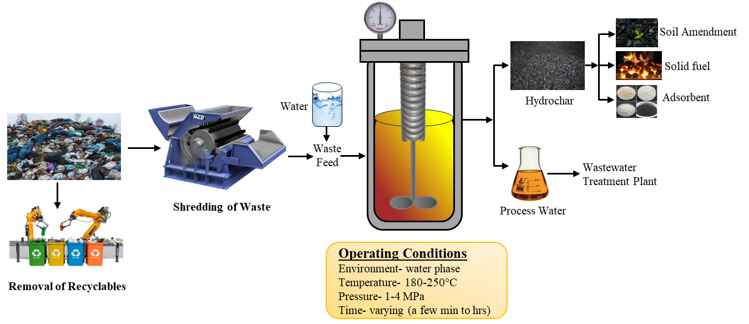

Figure: Hydrothermal carbonization process of MSW to resources (Durak, 2023)

### Biological treatment

#### Composting

Composting is the aerobic process of decomposition of organic MSW and converting waste into a valuable product called compost which can be used as soil conditioner, fertilizer, or manure (Álvarez-Alonso et al., 2024; Babu et al., 2021). Simultaneously, heat can also be recovered during the process (Babu et al., 2021). Klejment & Rosiński (2008) stated the process recovered energy between 3 and 8 MJ/kg of organic waste. The different composting methods are windrow composting, vermicomposting, vessel composting, sheet composting, static composting, and Indian Indore composting (Ayilara et al., 2020). Composting depends on several operating parameters such as moisture content, temperature, pH, oxygen level, and carbon-to-nitrogen ratio of the waste components. The process is highly dependent on the temperature, in the mesophilic range of temperature at 20-40 °C, mesophilic bacteria start the degradation of waste which leads to a rise in temperature. When the temperature rises > 40 °C, thermophilic microorganism accelerates waste decomposition, resulting in faster composting. The temperature > 55 °C kills the pathogens, making compost safer (Ayilara et al., 2020; Vaverková et al., 2020). The optimum temperature for the process is between 55 and 65 °C (Vaverková et al., 2020).

Composting has several benefits including low capital investment, maintenance and operation costs, lower environmental impacts, and a higher societal acceptance (Babu et al., 2021; Munir et al., 2021). Álvarez-Alonso et al. (2024) obtained that it is a sustainable waste management method for the organic fraction of MSW. In contrast, the process is time-consuming and requires a larger area (Ayilara et al., 2020). Furthermore, a major limitation of the process is that it emits an unpleasant odor which can reduce the living standards of surrounding localities (de Souza & Drumond, 2022). Thus, commercial-scale plants require an efficient control measure to minimize negative impact on the surroundings. Moreover, it can reduce waste mass by only around 40% (Munir et al., 2021).

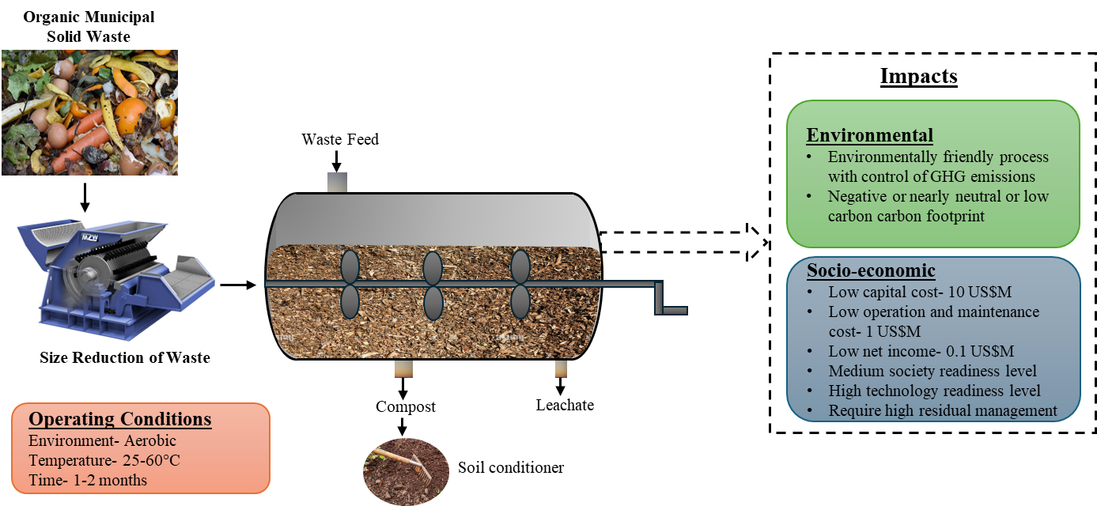

Figure: Composting of MSW (Munir et al., 2021)

Globally, around 19% of MSW undergo composting (Kaza et al., 2018). In Europe, approximately 53% of the organic fraction of MSW is treated through composting, with an installed capacity of 21 million tons. In 2020, around 40 million tons of MSW were treated through composting processes (Linden & Reichel, 2020). The process has become popular in developing nations, especially tropical regions, where the climatic conditions are favorable to composting (Nanda & Berruti, 2021). The countries with the largest proportion of MSW composted include Austria (31%), the Netherlands (27%), Switzerland (21%), and Luxembourg (20%). According to CPCB reports, India composted 18% of its MSW, primarily through vermicomposting (CPCB, 2022). As of 2023, India has 2285 working compost plants with a capacity of 71682 tons/day and 73 more under development with a capacity of around 1084 tons/day (MOHUA, 2023). Metropolitan cities of India have composting plants with a capacity between 300 and 500 tons/day (CPCB, 2022). In comparison, the USA composted 8.5% of MSW, while China and Sub-Saharan Africa region composted only 3% and 1%, respectively (Cao et al., 2023; Kaza et al., 2018).

#### Anaerobic digestion

Anaerobic digestion (AD) is the anaerobic biological process that degrades organic compounds of MSW with the help of anaerobic microbes to produce digestate and biogas. The process takes place in four stages namely, (1) hydrolysis which converts complex organic compounds into simple and soluble compounds, (2) acidogenesis which converts hydrolyzed compounds into volatile fatty acids, alcoholic and inorganic compounds, (3) acetogenesis which generates carbon dioxide, hydrogen and acetate by converting the compounds formed during former stage and (4) methanogenesis which decomposed organic matter and produce biogas (Babu et al., 2021). The main product of the process is biogas which predominantly contains 55-75% methane (CH4), 30-45% carbon dioxide (CO2), 1-2% hydrogen sulfide (H2S), 0-1 % hydrogen (H2), nitrogen (N2), and a trace amount of other gases such as carbon monoxide (CO) and oxygen (O2) (Hilkiah Igoni et al., 2008).

Biogas can generate energy with an efficiency of 35% and a generation capacity of 2.14 kW of electricity per m3 of biogas or use as a fuel for cooking and vehicles (Hilkiah Igoni et al., 2008; Varjani et al., 2022). The other byproduct is digestate which can be utilized as fertilizer as it is a mixture of several nutrients including nitrogen, phosphorus, potassium and other micro-nutrients (Awasthi et al., 2022). Additionally, lactic acid and succinic acid are other beneficial by-products of the process. There are several applications of lactic acid and succinic acid, whereby the former product is useful for degradable polymers and various acids (such as acrylic acid, and pyruvic acid) production. The latter has applications in polymer manufacturing and pharmaceutical industries (Richard et al., 2019). Product performance and yield depend on the feedstock characteristics and various operating parameters such as hydraulic retention time, organic loading rate, pH, temperature, moisture content and alkalinity (Munir et al., 2021; Subbarao et al., 2023).

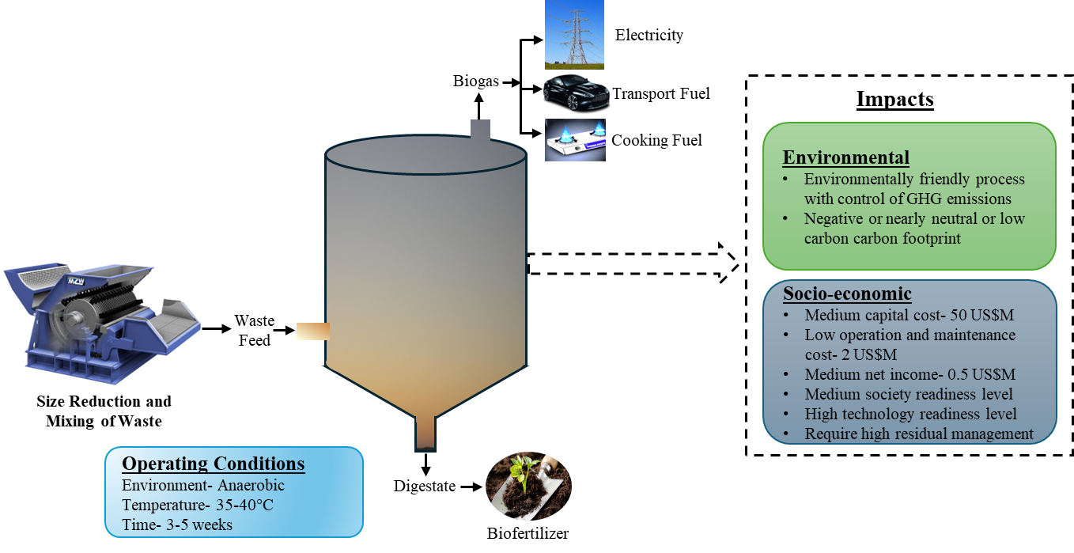

Figure: Resource recovery through anaerobic digestion process of MSW (Munir et al., 2021)

Anaerobic digestion is a widely attractive and recognized technology due to its environmentally friendly characteristics, as well as low maintenance and operational costs (Munir et al., 2021). It has a negative or nearly neutral or low carbon carbon footprint. Biogas application in electricity production and fuel for vehicles can minimize the GHG potential around 1269-1623 kg CO2-eq and 1006-1546 kg CO2-eq per ton of MSW, respectively (Subbarao et al., 2023). Chu et al. (2023) discovered that compared to composting and incineration, anaerobic digestion plays a significant role in reducing GHG emissions in Shanghai. Afrane et al. (2022) examined that AD is the most suitable process in developing nations due to the higher proportions of organics and moisture content in MSW composition. Moreover, the process has a higher level of social acceptance as compared to thermal processes. However, AD has a few limitations such as being time-consuming, low-quality products, the generation of inhibitors and comparatively inefficient as it can reduce only around 60% of MSW mass (Munir et al., 2021).

Globally, incineration and landfills have become limited use, while AD has emerged as an effective method for MSW to resource recovery due to stringent standards and environmental laws (Sondh et al., 2022). AD has become an attractive treatment for managing biodegradable waste in Europe. In Europe, around 47% of the biodegradable MSW is treated through AD, with an installed capacity of 17 million tons (Linden & Reichel, 2020). According to Global Methane Initiative (GMI), Canada and the US developed several AD plants with a capacity ranging from 25000 to 130000 tons per year. Moreover, several commercial AD plants are working successfully in various European countries including Denmark, Germany, Greece, Italy, etc. Furthermore, the process is estimated to generate approximately 2.4 to 4.1% of Vietnam’s electricity from MSW between 2015 and 2025. Household AD plants are widespread in India and China to treat food waste. According to the SATAT program, India plans to develop 5000 AD plants efficiently producing 15 million metric tons of biogas and 50 million metric tons of digestate. Currently, 99 AD plants are working with a capacity of 2288 tons/day, additionally, 338 tons/day capacity of 5 more plants are under development (MOHUA, 2023).

#### Landfilling

Landfilling is the least favorable end-of-pipe and long-term treatment process, involving the decomposition of organic compounds and storage of inert material (Babu et al., 2021). Unsanitary landfills are highly uncontrolled but sanitary landfills involve the controlled decomposition of waste and recovery of landfill gas (Kumar & Samadder, 2017). Waste degradation occurs through a series of physical, chemical and biological processes. The two major products, landfill leachate and gas can be recovered from sanitary landfills. Landfill gas is a composition of methane (CH4), carbon dioxide (CO2) and a small proportion of water vapor and other non-methane organic matter. It has a methane potential of 100 m3 per ton of OFMSW and can be used for electricity generation by collecting through a network of wells and pipes (Babu et al., 2021; Prajapati et al., 2021). However, its low methane (CH4) concentration and co-presence of hydrogen sulfide (H2S) make it a low-quality gas (Dada & Mbohwa, 2017). Moreover, the generation of landfill gas decreases with time (Mor & Ravindra, 2023). Proper collection and treatment of landfill leachate is essential to prevent groundwater contamination, as it contains various acids (such as fulvic and humic acid), and volatile organic compounds (Awasthi et al., 2022). Additionally, untreated leachate poses an impact on human health and the environment (Yaman et al., 2020).

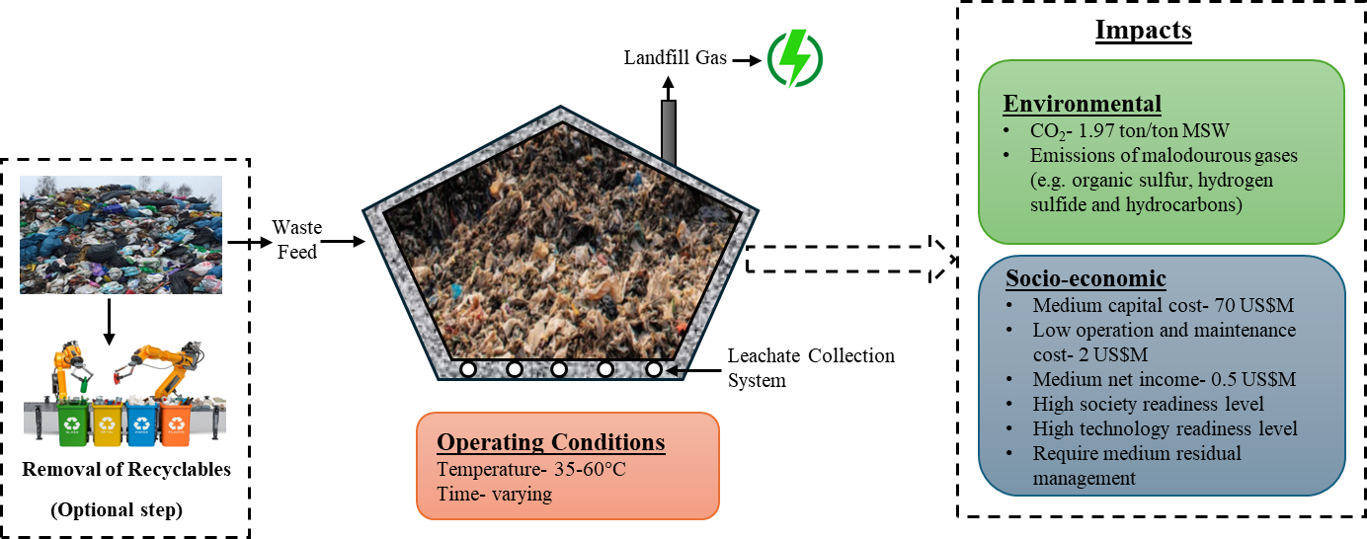

Figure: Landfilling with gas recovery of MSW (Munir et al., 2021)

Landfilling is a widely used and affordable treatment process for MSW, especially in developing countries as it does not require skilled labour for operation. Moreover, it has a long service life of 30 to 50 years and low maintenance and operation costs (Kumar & Samadder, 2017; Munir et al., 2021). However, developed nations are discouraging landfilling due to strict environmental standards and are promoting waste recycling and reduction initiatives (Kumar & Samadder, 2017). Furthermore, the quality and yield of the biogas are very poor, producing only about 50 % of biogas from 100 % of the MSW feedstock (Hoang et al., 2022). The major disadvantage of the process is emissions of malodorous gases such as organic sulfurs, hydrogen sulfide (H2S), alkylbenzenes and other hydrocarbons which produce unpleasant odors in surroundings during the decomposition of waste (Mor & Ravindra, 2023). It also emits approximately 1.97 tons of CO2 per ton of MSW, resulting in an adverse impact on climate (Munir et al., 2021). Kumar & Samadder (2022) observed that landfills have a major environmental impact compared to other MSW resource recovery technologies. On the other hand, researchers have observed that landfilling with high landfill gas collection efficiency of greater than 81% and methane recovery resulted in lower GHG emissions compared to the incineration process (Anshassi et al., 2021, 2022).

Globally around 40% of waste is disposed of in landfills, with only approximately 7.7% of that waste being disposed of in sanitary landfills with landfill gas collection systems (Kaza et al., 2018).

As per the European Environmental Agency (EEA), European countries reduced landfilling from 23% to 16% between 2010 and 2020. North American countries including Bermuda, Canada, and the United States disposed of more than half of their waste in sanitary landfills (Kaza et al., 2018). However, in the United States number of landfills decreased from 1908 to 1269 between 2010 and 2018 (Environmental Protection Agency et al., 2018). In 2020, Latin America and the Caribbean region disposed of around 43% of their waste in sanitary landfills with landfill gas recovery. Moreover, many countries focused on energy recovery through landfilling, including Colombia, El Salvador, and Mexico treated 70 – 90% of MSW via sanitary landfills. On the other hand, in the European region, only Norway has a landfill with a gas collection facility, disposing of approximately 4% of its total waste generated in 2020 (*What A Waste Global Database*, 2021).

#### Biofuel production

MSW contains a significant fraction of organic compounds mainly due to food and garden waste which has greater potential to recover biofuels including bioethanol, biodiesel and biohydrogen via biological processes. Bioethanol production from OFMSW includes four stages namely, pretreatment to modify the structural characteristics of OFMSW, followed by enzymatic hydrolysis to break macromolecular compounds into monomolecular compounds. Finally, fermentation converts carbohydrates to alcohol and produces ethanol (Barampouti et al., 2019). Biodiesel is another biofuel that can be produced from the lipids of MSW. MSW contains 10 to 15% of lipids which can be extracted using various methods such as conventional, soxhlet and supercritical extraction (Karmee, 2016). In addition to bioethanol and biodiesel, biohydrogen could also be generated through biological processes mainly, photo-biological processes, microbial electrolysis and dark fermentation (Jensen et al., 2022; Varjani et al., 2022). These processes have the efficiency of producing 142 kJ of energy per gram of waste (Ali et al., 2020).

Biofuel could replace diesel and gasoline, decreasing the dependency on petroleum fuel. Biodiesel is utilized as a fuel in Europe, the US and many other countries (Jensen et al., 2022; Karmee, 2016). Furthermore, it can reduce between 70 and 90% of GHG emissions, reducing air pollution (Barampouti et al., 2019). On the downside, the process required high investment and operating costs. Moreover, these processes are limited to carbohydrate and lipid-rich compounds of MSW (Karmee, 2016). The complex composition of MSW has various impacts such as the co-generation of hazardous chemicals and pollutants, reducing the quality of biofuels (Hai et al., 2023; A. T. Hoang et al., 2022).

According to ETIP Bioenergy, three commercial plants worldwide are either working or under development to produce bioethanol from MSW, located in Spain, Canada and the United States. The plant in Spain has the capacity to recover 60 L of bioethanol per ton of MSW which can be utilized as fuel. In Canada, the plant operating by Enerkem has a production capacity between 38 and 152 million liters per year of ethanol from non-recyclable MSW. On the other hand, in developing countries the process is unexplored, and lab-scale research is being conducted to understand the suitability of the process on a commercial scale (Thomas & Soren, 2020). Thapa et al., 2019 conducted a lab-scale study on ethanol recovery from kitchen waste and estimated 28.53 L ethanol per ton of wet waste.

Table: Summary of resource recovery technologies (Still working and improving it)

|  |  |  |  |  |  |  |  |  |
| --- | --- | --- | --- | --- | --- | --- | --- | --- |
| **Process**  **Criteria** | **Incineration** | **Pyrolysis** | **Gasification** | **Hydrothermal liquefaction** | **Hydrothermal carbonization** | **Anaerobic digestion** | **Composting** | **Scientific Landfilling** |
| Principle | Complete oxidation | Thermal decomposition of organic material | Partial oxidation of waste in a controlled environment | Hydrothermal conversion of wet waste into bio-oil | Hydrothermal conversion of wet waste into hydrochar | Biological decomposition of organic waste | Natural decomposition of organic waste | Decomposition of organic waste and storage of inert material |
| Operating Temperature (°C) | 800-1200 | 300-1200 | 700-1100 | 250-400 | 180-250 | 35-40 | 25-60 | 35-60 |
| Operating Time | Varying | 0.5 sec- 100 min | 30-90 min | 1-40 min | Varying | 3-5 weeks | 1-2 month | Varying |
| Operating Environment | Presence of oxygen | Absence of oxygen | Controlled supply of oxygen | Water phase | Presence of water | Absence of oxygen | Presence of air and moisture | NA |
| Pretreatment | Shredding | Sorting and shredding | Sorting and shredding | Shredding | Shredding | Sorting, shredding and sterilization | Sorting and shredding | Sorting |
| Feedstock Composition of MSW |  |  |  |  |  |  |  |  |
| Waste to resource | Flue gas and ash | Bio-oil, biochar, syngas | Syngas | Bio-oil | Hydrochar | Biogas and digestate | Compost | Landfill gas |
| MSW mass reduction (wt. %) | 70-80 | 80-90 | 80-90 | 90-95 | 90-95 | 60 | 50 | 60 |
| Net energy production (kWh/ton of MSW) | 544 | 571 | 685 |  |  | 100-160 | -(30-40) | 50-100 |
| Environmental Impact | Emission of CO2, SOx, NOx, PM and dioxins | Emission of CO2, SOx, NOx, PM and HCl | Emission of CO2, SOx, NOx, PM, Hg and HCl |  |  | Environmentally friendly process with control of GHG emissions | Environmentally friendly process with control of GHG emissions | Groundwater pollution due to leachate generation |
| Socio-economic Impact |  |  |  |  |  |  |  |  |
| Plant Life (years) | 30 | 20 | 20-30 | 20 | 20 | 15-20 | 10-15 | 30 |
| References | (Munir et al., 2019; Nanda & Berruti, 2021; Young, 2010) | (Andooz et al., 2023; Munir et al., 2019; Young, 2010) | (Hameed et al., 2021; Munir et al., 2019; Young, 2010) | (Durak, 2023; Munir et al., 2021) | (Durak, 2023; Munir et al., 2021) | (Munir et al., 2021; Nanda & Berruti, 2021) | (Munir et al., 2021; Nanda & Berruti, 2021) | (Munir et al., 2021; Varjani et al., 2022) |

## Challenges and recommendations related to the implementation of recycling and resource recovery technologies of municipal solid waste

The challenges and recommendations for addressing them were considered across five aspects: technological, economic, environmental and climate change, social and implementation of policies and rules. Figure demonstrates the summary of various challenges and recommendations for the implementation of resource recovery and recycling of MSW.

### Technological aspect

#### Heterogenous MSW composition

The heterogeneous nature of MSW affects the performance and efficiency of recycling and resource recovery technologies.

#### Collection and segregation of waste

The collection and segregation of MSW are one of the major challenges of effective MSWM mainly in low income countries where the urbanization rate is low. In comparison, the MSW collection is widely available in middle and high income countries (Zhang et al., 2024). On the other hand, waste collection efficiency is low in emerging countries due to inadequate vehicles and unorganized or no storage facilities (Pheakdey et al., 2022). Furthermore, waste sorting at source is very limited in many developing countries due to a lack of recycling and recovery awareness (Adeleke et al., 2021; Knickmeyer, 2020). Non-segregated MSW may contaminate recyclable material, decreasing the recycling rate and increasing the cost (Fidelis et al., 2023; Themelis, 2023). The composition of MSW having high moisture content affects the process efficiency of thermal processes (e.g. gasification and pyrolysis) as well as increases the overall cost of the process (Hameed et al., 2021).

The collection efficiency can be increased by providing door-to-door collection in urban as well as rural areas of the country. Moreover, optimization of the collection route increases the collection rate (Ferronato et al., 2018). MSW sorting can be improved in developing nations by utilizing multicompartment bins or containers in private as well as public areas, as seen in developing countries (Harbiankova & Kalinowski, 2023; M. Singh et al., 2024). Furthermore, encouraging people and providing knowledge on the importance of MSW sorting and its benefits improve segregation at source (Dickella Gamaralalage et al., 2022; Knickmeyer, 2020). Additionally, implementation of extended producer responsibility (EPR) where producers are responsible for disposing of their waste. It includes various tasks including segregation of waste and promoting recycling and recovery. Apart from this, use of artificial intelligence such as digital waste bins and waste sorting robots helps to improve the collection and segregation of MSW (Dickella Gamaralalage et al., 2022; M. Singh et al., 2024). However, the implementation of these technologies requires comparatively more financial support, creating a challenge to adopt them globally (M. Singh et al., 2024). Moreover, the inclusion of private companies that are experts in recycling will improve the recycling rate by promoting collection at the source and establishing plants for segregation (Ferronato et al., 2018; Sasmoko et al., 2022).

#### Lack of infrastructure and technical experts

Outdated infrastructure and a lack of experts in the field pose difficulties in the implementation of resource recovery technologies especially in developing nations (Ali et al., 2020; Awasthi et al., 2022). Whereas well-funded governments in developed countries can invest more funds in infrastructure (Zhang et al., 2024). In many developing nations, operators face several challenges such as the operation and maintenance of machinery as majorly are of foreign origins (M. Singh et al., 2024). The adoption rate of plasma gasification is low due to the requirement of specific infrastructure that can sustain high temperatures and the lack of technical experts (Munir et al., 2019). Moreover, improper training, lower standards of working environment and lack of protection may result in a risk to the operator’s life (M. Singh et al., 2024).

Collaborating with the private sector for infrastructure development reduces financial pressure. However, the involvement of private companies influences the operation and maintenance of recycling and recovery technologies (Zhang et al., 2024). It requires an organized framework of government surveillance, enforcement of contracts and adequate fiscal support for its successful execution. The challenge of a lack of technical experts in the field can be overcome by putting efforts into training and capacity building which enhance the knowledge and efficiency of the operators (Pheakdey et al., 2022; Tun et al., 2020). It can be achieved by designing training, including various aspects of effective management of MSW such as innovative technologies, financing and planning (M. Singh et al., 2024).

### Economic aspect

There are several economic challenges involved with the implementation of value-added material and energy recovery technologies of MSW, mainly high investment, and high operation and maintenance costs. In fact, the lack of finances is normal for waste authorities in developing nations (Adeleke et al., 2021; Zhang et al., 2024). It is challenging to invest for effective management of MSW through resource recovery and recycling in low to middle-economy countries due to a lack of financial sustainability, lower rate of participation of the private sector and improper investment (Ferronato et al., 2018; Hemidat et al., 2022; Zhang et al., 2024).

Various recommendations to address the above challenges include allocating more funds to recovery and recycling technologies, collaboration between the government and private sector, financial help to low and middle income countries, and tipping fees (Tun et al., 2020). The development of cooperation between the public and private sectors can fulfills financial sustainability (Hemidat et al., 2022; Sasmoko et al., 2022). The revenue generated by selling electricity, value-added materials, or heat from MSW can compensate for investment and create a source of income (Munir et al., 2019; M. Singh et al., 2024). Moreover, nonconventional processes such as pyrolysis and gasification produce higher net income (Munir et al., 2021). Munir et al. (2019) found that the operation of plasma gasification can be cheaper by collecting a tipping fee. Moreover, the study observed that it is more economical than conventional treatment (Munir et al., 2019).

### Environmental and climate change

MSW to material and energy recovery reduces the direct disposal of waste. However, resource recovery technologies, mainly thermal and hydrothermal technologies emit several pollutants including CO2, SOx, NOx and other VOCs which may cause air pollution. It also poses a risk to human health (Kumar & Samadder, 2017). Whereas biological processes such as composting and sanitary landfilling produce leachate during the treatment of MSW. Direct disposal and improper treatment of leachate may result in water pollution due to the presence of various organic and acidic compounds (Awasthi et al., 2022; Yaman et al., 2020). Furthermore, residual products of incineration and gasification (e.g. ash and slag) contain heavy metals, creating soil pollution (Munir et al., 2021; Van Caneghem et al., 2019).

However, thermal processes with carbon capture and storage technology made these processes environmentally friendly. It helps to reduce emissions of CO2 and mitigates climate change (Dal Pozzo et al., 2023; Wienchol et al., 2020). Moreover, it will significantly reduce the use of fossil fuels for energy generation (Ahmad et al., 2024). Gasification using plasma was found to be a more sustainable and effective treatment for resource recovery from MSW (Hameed et al., 2021). Ramos et al. (2019) discovered that plasma gasification is more sustainable than gasification and incineration processes, emitting lower pollutants in the air and water. Another study of biofuel production from MSW observed that the production of biofuels will mitigate climate change (Aracil et al., 2017).

### Social aspect

#### Public perception and acceptance

Public acceptance is one of the major barriers to the implementation of resource recovery technologies. This is likely due to a lack of knowledge of the long-term benefits of these methods. Additionally, public opposition is mainly due to emissions of harmful pollutants and toxic compounds, resulting in health risks (Kumar & Samadder, 2017). Not In My Backyard (NIMBY) is a common constraint where the community protests the construction of recovery facilities near their locality, mainly due to air, noise, and soil pollution (Malinauskaite et al., 2017; Mor & Ravindra, 2023). Even high income countries (i.e. developed countries) are encountering public opposition due to assumed health risk (Kumar & Samadder, 2017).

Societal acceptance towards recycling and recovery of MSW can be achieved through transparent communication with the public by highlighting benefits, risks and the necessity of safety measures (M. Singh et al., 2024). Involve stakeholders and the local public in the planning of a sustainable MSWM system (Tun et al., 2020). Developing community trust and changing attitudes for adoption of advanced technologies for sustainable MSWM. Regular monitoring and reporting of the treatment facilities should be accessible to the public to build trust (M. Singh et al., 2024). Adoption of advanced technologies such as carbon storage and capture to minimize the emissions of pollutants (Wienchol et al., 2020).

#### Lack of awareness and education

Implementation of recycling and waste recovery significantly depends on public participation in waste sorting which is difficult to obtain either due to a lack of awareness and knowledge or their low willingness (Ferronato et al., 2018; Prajapati et al., 2021). Deus et al. (2022) have observed that the level of education influences the effectiveness of MSWM, as educated people are more likely to support recycling. Moreover, the public may have a limited understanding of the advanced technologies and their environmental as well as socio-economic benefits. This limited knowledge and understanding can lead to resistance and misperception (Calabrò & Satira, 2020; M. Singh et al., 2024).

To tackle these barriers, it is essential to increase public awareness by conducting educational programs on sustainable waste management, focusing on recycling and recovery technologies. Additionally, emphasize the long-term advantages of these processes, and their role and importance in developing sustainable cities (Calabrò & Satira, 2020; Tun et al., 2020). Moreover, the participation of communities such as non-governmental organizations (NGOs), municipalities, and local government to raise public awareness and participation in effective MSWM (Dickella Gamaralalage et al., 2022). The provision of free waste bins and collection services may encourage people and change their behavior toward waste segregation (Zhang et al., 2024). Furthermore, raising broad awareness that it has not only environmental benefits but also creates opportunities for entrepreneurship and job (M. Singh et al., 2024).

#### Unorganized informal sector

In developing countries, the collection, sorting, and commercialization of recyclable materials of MSW is mainly carried out by the informal sector. Globally, between 2% and 31 % of MSW is collected for recycling by informal sectors mainly in upper middle, lower middle and low income countries. Whereas only 2 to 10% of MSW is collected for recycling by formal sectors (Silva de Souza Lima Cano et al., 2022). Waste pickers are the major contributor to informal recycling, collecting waste from dumpsites, open landfills and storage facilities (Morais et al., 2022). Apart from waste pickers, small-scale waste buyers, dealers and warehouse owners also play a vital role in informal recycling (R. Singh, 2021). Formal recycling is poorly organized and funded mainly in middle to low income countries. Hence, informal recycling continues to expand which is unorganized and not part of MSWM (Morais et al., 2022). Moreover, informal recyclers face several challenges such as health hazards, poor living standards and working conditions, child labor, harassment, and low income (Calabrò & Satira, 2020; R. Singh, 2021). On the other hand, it contributes to environmental and economic benefits such as reduced GHG emissions, increased rate of recycling, mitigate climate change and minimizing economic burden (Fidelis et al., 2023). Furthermore, it can also contribute to achieving Sustainable Development Goals (SDGs), i.e. SDG 1, 3, 5, 6, 8, 9, 11, 12, 13 and 14 (R. Singh, 2021). Tong et al. (2021) found that 15-20 % of total waste is recycled by informal sectors in Vietnam which also minimizes the cost of the MSWM system and creates income opportunities for impoverished communities.

Thus, the inclusion of the informal sector in the formal sector is necessary to achieve environmental, economic, and social sustainability (Fidelis et al., 2023; Silva de Souza Lima Cano et al., 2022). Collaboration between urban local bodies, various informal stakeholders, and NGOs can integrate informal sectors into the MSWM system (Ferronato et al., 2018; R. Singh, 2021). Moreover, the organization of training and awareness programs, provision of sanitation facilities and the distribution of protective gear and other equipment to ensure their health and safety can encourage them to join formal recycling systems (R. Singh, 2021).

### Policy and regulatory framework

Government policy and regulatory framework are essential for developing the recycling and recovery technologies of MSW. The absence of a comprehensive policy framework and financial governance system for the implementation of new technologies significantly prevents the achievement of sustainable MSWM (M. Singh et al., 2024). Other major policy barriers are lack of objectivity, complex and lengthy tendering process and permitting which possibly delay project implementation (Harbiankova & Kalinowski, 2023). Furthermore, the absence of government support and legislation for the utilization of recovered resources such as energy, biochar, fertilizer, and recycled waste affects corporations’ ability to generate revenue (Ali et al., 2020). Apart from this, the policymakers are facing difficulties in drafting green policies due to a lack of financial and community support (Ali et al., 2020; Deus et al., 2022). The poor coordination between various stakeholders such as government agencies, private companies, and the community, resulted in inefficient implementation of recycling and recovery strategies (Tun et al., 2020).

For the effective implementation of resource recovery technologies, policymakers should introduce different policy tools such as producer responsibility schemes (PRS), polluter pays principle, and ban on landfill disposal which may change the attitude of people towards effective MSWM (Ferronato et al., 2018; Z. Zhang et al., 2024). Development of integrated policy which includes waste recycling, recovery and circular economy principles (Harbiankova & Kalinowski, 2023). Furthermore, during the planning and design of the policy framework, collaboration among regional governments, involvement of all stakeholders, public-private partnerships, and cooperation with international organizations could enhance the implementation and effectiveness of recycling and recovery projects to obtain sustainable MSWM (M. Singh et al., 2024; Tun et al., 2020).

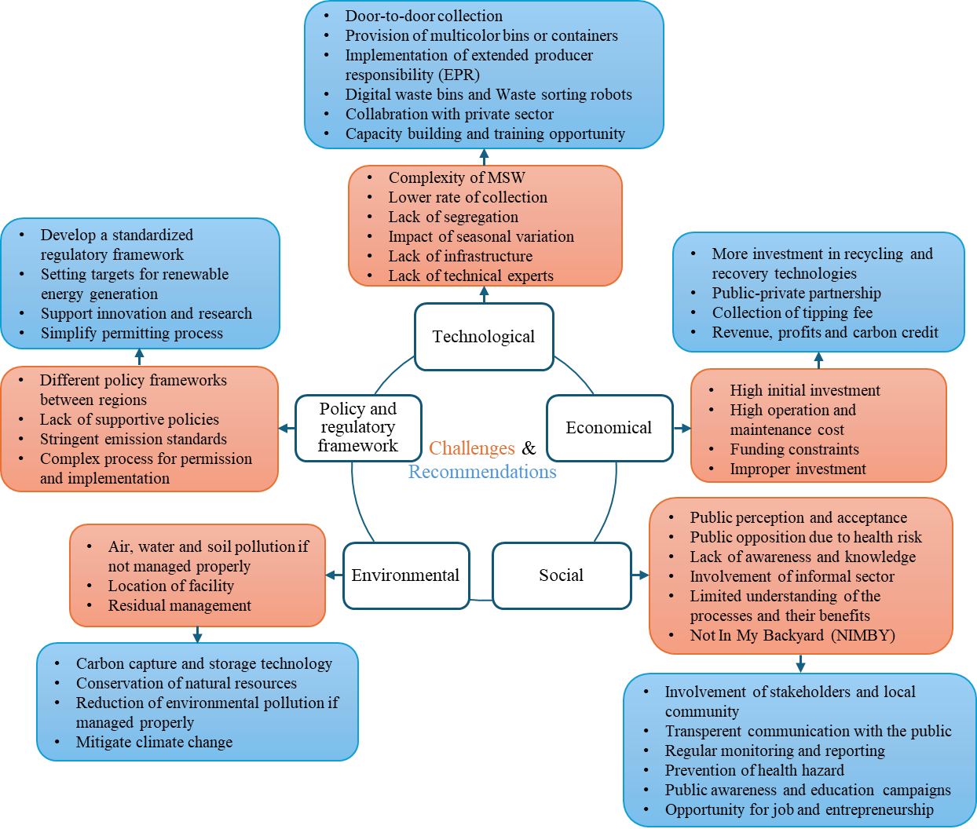

Figure: Summary of various challenges and recommendations for the implementing resource recovery and recycling strategies of MSW

## Innovation/recent trend in MSWM

The rapid growth of technological advancement is a major driving source of innovation in MSWM, focusing on circular economy and sustainability. Technological advancements such as use of Artificial Intelligence (AI), the Internet of Things (IoT), gamification, mobile applications, solar-powered compactor bins, robotics, and automation have improved recycling and resource recovery efficiency (Babu et al., 2021; M. Singh et al., 2024).

Artificial intelligence-driven waste bins utilize sensors and machine learning algorithms to automatically identify and categorize waste. It also monitors waste accumulation in real time and optimizes waste collection schedules (M. Singh et al., 2024; Sondh et al., 2022). Moreover, waste sorting robots have been developed using sensors, cameras and AI algorithms to categorize different waste materials such as paper, plastic, glass and food waste (M. Singh et al., 2024). Furthermore, AI applications for real-time environmental monitoring around waste treatment technologies such as incineration and composting, assist in complying with environmental standards and minimizing environmental impact (Babu et al., 2021). In recent years, many countries, e.g., Spain, Finland, Austria and India have integrated MSW recycling and sorting practices with gamification to promote sustainable waste management. This approach has been discovered to effectively change public behavior, encouraging waste segregation and recycling activities. (González-Briones et al., 2019; Haas et al., 2022).

Bildarchiv et al. (2023) developed a solid waste management (SWM) GHG calculator to estimate the GHG impacts of different waste management practices and to assist decision-makers in choosing the most appropriate technologies.

## Possible roadmap for the circular economy using recycling and resource recovery technologies of MSW in developed and developing countries

(Adeleke et al., 2021; Awasthi et al., 2022; Munir et al., 2021)

## Resource recovery and recycling of MSW towards the achievement of the UN-SDGs

The proper implementation of MSW recycling and resource recovery strategies can contribute to several UN-SDGs as presented in Table. Various studies have discovered that energy recovery using thermal process and biogas and fertilizer recovery through anaerobic digestion directly contribute to UN-SDGs (Dada & Mbohwa, 2018; Rahman et al., 2019; Yong et al., 2021). Dada & Mbohwa (2018) stated that renewable energy produced from MSW is affordable, clean, reliable and sustainable, directly contributing to SDG 7 (Affordable and Clean Energy). According to the World Biogas Association, the anaerobic digestion of MSW for biogas and fertilizer recovery can help to achieve multiple SDGs. It supports SDG 3 (good health and well-being) by minimizing pollution, SDG 6 (clean water and sanitation) by preventing water contamination, SDG 7 (affordable and clean energy) by producing renewable energy, SDG 9 (industry, innovation and infrastructure) by encouraging innovations and technologies for effective MSWM, SDG 11 (sustainable cities and communities) by improving air quality, sanitation and hygiene, SDG 13 (climate action) by reducing GHG emissions, SDG 15 (life on land) by preventing land degradation (worldbiogasassociation.org, 2018).

Sasmoko et al. (2022) reported that recycling of MSW contributes to SDG 11 by reducing GHG emissions, mitigating climate change, and enhancing the livability of cities and communities. The study also found that recycling minimizes the need for virgin materials, reduces waste, and promotes CE which helps to achieve SDG 12. Furthermore, R. Singh (2021) concluded that integration of the informal sector into formal recycling can contribute to ten SDGs. It plays a crucial role in attaining SDG 1, i.e. no poverty by providing a constant source of income to waste pickers and SDG 5, i.e. gender equality by providing an equal job to women. Moreover, informal waste recycling creates jobs and supports economic growth by transforming waste into valuable goods, thus contributing to SDG 8 (decent work and economic growth) (R. Singh, 2021; Srinivas, 2020).

Table: summary of the achievement of UN-SDGs through recycling and resource recovery of MSW

|  |  |
| --- | --- |
| **Sustainable Development Goals (SDGs)** | **Contribution of MSW recycling and resource recovery strategies** |
| Goal 1: no poverty | * Provide an opportunity to waste recycling workers to generate income |
| Goal 3: good health and well-being | * Minimize air pollution by substituting domestic fuels with biogas and renewable energy * Recycling of waste reduces hazardous emissions and diseases. |
| Goal 5: gender equality | * Provide equal job opportunities to women by integrating the informal recycling sector into the formal recycling sector |
| Goal 6: clean water and sanitation | * Reduce water pollution by eliminating dumping and minimizing the release of hazardous chemicals into water bodies |
| Goal 7: affordable and clean energy | * Generates renewable energy from MSW * Contribute to the availability of affordable and clean energy |
| Goal 8: decent work and economy growth | * Create jobs * Support economic growth |
| Goal 9: industry, innovation and infrastructure | * Encourage innovative technologies and infrastructure * Support sustainable industrial development |
| Goal 11: sustainable cities and communities | * Provide a cleaner and healthier environment * Enhance the livability of cities and communities |
| Goal 12: responsible consumption and production | * Recycling reduces the need for virgin raw materials, thereby minimizing resource depletion * Encourage waste prevention and circular economy |
| Goal 13: climate action | * Minimize greenhouse gas emissions associated with waste disposal * Mitigate the effect of climate change |
| Goal 14: life below water | * Reduce direct disposal of waste in the oceans |
| Goal 15: life on land | * Prevent land degradation by avoiding direct disposal and landfilling |

# Conclusion

# References

Abis, M., Bruno, M., Kuchta, K., Simon, F.-G., Grönholm, R., Hoppe, M., & Fiore, S. (2020). Assessment of the Synergy between Recycling and Thermal Treatments in Municipal Solid Waste Management in Europe. *Energies*, *13*(23), 6412. https://doi.org/10.3390/en13236412

Adeleke, O., Akinlabi, S., Jen, T. C., & Dunmade, I. (2021). Towards sustainability in municipal solid waste management in South Africa: a survey of challenges and prospects. In *Transactions of the Royal Society of South Africa* (Vol. 76, Issue 1). https://doi.org/10.1080/0035919X.2020.1858366

Afrane, S., Ampah, J. D., Agyekum, E. B., Amoh, P. O., Yusuf, A. A., Fattah, I. M. R., Agbozo, E., Elgamli, E., Shouran, M., Mao, G., & Kamel, S. (2022). Integrated AHP-TOPSIS under a Fuzzy Environment for the Selection of Waste-To-Energy Technologies in Ghana: A Performance Analysis and Socio-Enviro-Economic Feasibility Study. *International Journal of Environmental Research and Public Health*, *19*(14). https://doi.org/10.3390/ijerph19148428

Ahmad, W., Hassan, M., Masud, S. F. Bin, Amjad, M. S., Samara, F., Zeshan, Anwar, M., Rafique, M. Z., & Nawaz, T. (2024). Socio-economic benefits and policy implications of generating sustainable energy from municipal solid waste in Pakistan. *Energy and Climate Change*, *5*. https://doi.org/10.1016/j.egycc.2023.100124

Ali, J., Rasheed, T., Afreen, M., Anwar, M. T., Nawaz, Z., Anwar, H., & Rizwan, K. (2020). Modalities for conversion of waste to energy — Challenges and perspectives. *Science of The Total Environment*, *727*, 138610. https://doi.org/10.1016/j.scitotenv.2020.138610

Álvarez-Alonso, C., Pérez-Murcia, M. D., Sánchez-Méndez, S., Martínez-Sabater, E., Irigoyen, I., López, M., Nogués, I., Paredes, C., Orden, L., García-Rández, A., & Bustamante, M. Á. (2024). Municipal Solid Waste Management in a Decentralized Composting Scenario: Assessment of the Process Reproducibility and Quality of the Obtained Composts. *Agronomy*, *14*(1). https://doi.org/10.3390/agronomy14010054

Andooz, A., Eqbalpour, M., Kowsari, E., Ramakrishna, S., & Ansari Cheshmeh, Z. (2023). A comprehensive review on pyrolysis from the circular economy point of view and its environmental and social effects. *Journal of Cleaner Production*, *388*, 136021. https://doi.org/10.1016/j.jclepro.2023.136021

Anshassi, M., Sackles, H., & Townsend, T. G. (2021). A review of LCA assumptions impacting whether landfilling or incineration results in less greenhouse gas emissions. *Resources, Conservation and Recycling*, *174*, 105810. https://doi.org/10.1016/j.resconrec.2021.105810

Anshassi, M., Smallwood, T., & Townsend, T. G. (2022). Life cycle GHG emissions of MSW landfilling versus Incineration: Expected outcomes based on US landfill gas collection regulations. *Waste Management*, *142*, 44–54. https://doi.org/10.1016/j.wasman.2022.01.040

Aracil, C., Haro, P., Giuntoli, J., & Ollero, P. (2017). Proving the climate benefit in the production of biofuels from municipal solid waste refuse in Europe. *Journal of Cleaner Production*, *142*, 2887–2900. https://doi.org/10.1016/j.jclepro.2016.10.181

Awasthi, S. K., Sarsaiya, S., Kumar, V., Chaturvedi, P., Sindhu, R., Binod, P., Zhang, Z., Pandey, A., & Awasthi, M. K. (2022). Processing of municipal solid waste resources for a circular economy in China: An overview. *Fuel*, *317*. https://doi.org/10.1016/j.fuel.2022.123478

Ayilara, M., Olanrewaju, O., Babalola, O., & Odeyemi, O. (2020). Waste Management through Composting: Challenges and Potentials. *Sustainability*, *12*(11), 4456. https://doi.org/10.3390/su12114456

Babu, R., Prieto Veramendi, P. M., & Rene, E. R. (2021). Strategies for resource recovery from the organic fraction of municipal solid waste. *Case Studies in Chemical and Environmental Engineering*, *3*, 100098. https://doi.org/10.1016/j.cscee.2021.100098

Barampouti, E. M., Mai, S., Malamis, D., Moustakas, K., & Loizidou, M. (2019). Liquid biofuels from the organic fraction of municipal solid waste: A review. *Renewable and Sustainable Energy Reviews*, *110*, 298–314. https://doi.org/10.1016/j.rser.2019.04.005

Barracco, F., Demichelis, F., Sharifikolouei, E., Ferraris, M., Fino, D., & Tommasi, T. (2023). Life cycle assessment for the production of MSWI fly-ash based porous glass-ceramics: Scenarios based on the contribution of silica sources, methane aided, and energy recoveries. *Waste Management*, *157*, 301–311. https://doi.org/10.1016/j.wasman.2022.12.013

Bildarchiv, K., Net Giz, / Photothek, Regina, /, Giz, T., & Yadav, J. (2023). *SWM-GHG Calculator (2023)-Life Cycle Assessment approach TOOL FOR CALCULATING GREENHOUSE GASES (GHG) IN SOLID WASTE MANAGEMENT (SWM) Sponsored and financed by Developed by*. www.ifeu.de

Calabrò, P. S., & Satira, A. (2020). Recent advancements toward resilient and sustainable municipal solid waste collection systems. *Current Opinion in Green and Sustainable Chemistry*, *26*, 100375. https://doi.org/10.1016/j.cogsc.2020.100375

Cao, X., Williams, P. N., Zhan, Y., Coughlin, S. A., McGrath, J. W., Chin, J. P., & Xu, Y. (2023). Municipal solid waste compost: Global trends and biogeochemical cycling. *Soil & Environmental Health*, *1*(4), 100038. https://doi.org/10.1016/j.seh.2023.100038

Chan, W. P., Veksha, A., Lei, J., Oh, W.-D., Dou, X., Giannis, A., Lisak, G., & Lim, T.-T. (2019). A hot syngas purification system integrated with downdraft gasification of municipal solid waste. *Applied Energy*, *237*, 227–240. https://doi.org/10.1016/j.apenergy.2019.01.031

Chen, D. M. C., Bodirsky, B. L., Krueger, T., Mishra, A., & Popp, A. (2020). The world’s growing municipal solid waste: trends and impacts. *Environmental Research Letters*, *15*(7). https://doi.org/10.1088/1748-9326/ab8659

Chu, Z., Li, Q., Zhou, A., Zhang, W., Huang, W., & Wang, J. (2023). Strategy formulation path towards zero-waste of municipal solid waste: A case study from Shanghai. *Journal of Cleaner Production*, *418*, 138091. https://doi.org/10.1016/j.jclepro.2023.138091

CPCB. (2022). *MSW_AnnualReport_2020-21*. https://cpcb.nic.in/uploads/MSW/MSW_AnnualReport_2020-21.pdf

Dabe, S. J., Prasad, P. J., Vaidya, A. N., & Purohit, H. J. (2019). Technological pathways for bioenergy generation from municipal solid waste: Renewable energy option. *Environmental Progress & Sustainable Energy*, *38*(2), 654–671. https://doi.org/10.1002/ep.12981

Dada, O., & Mbohwa, C. (2017). Biogas Upgrade to Biomethane from Landfill Wastes: A Review. *Procedia Manufacturing*, *7*, 333–338. https://doi.org/10.1016/j.promfg.2016.12.082

Dada, O., & Mbohwa, C. (2018). Energy from waste: A possible way of meeting goal 7 of the sustainable development goals. *Materials Today: Proceedings*, *5*(4), 10577–10584. https://doi.org/10.1016/j.matpr.2017.12.390

Dal Pozzo, A., Lucquiaud, M., & De Greef, J. (2023). Research and Innovation Needs for the Waste-To-Energy Sector towards a Net-Zero Circular Economy. *Energies*, *16*(4). https://doi.org/10.3390/en16041909

de Souza, L. C. G., & Drumond, M. A. (2022). Decentralized composting as a waste management tool connect with the new global trends: a systematic review. *International Journal of Environmental Science and Technology*, *19*(12), 12679–12700. https://doi.org/10.1007/s13762-022-04504-1

Deus, R. M., Esguícero, F. J., Battistelle, R. A. G., & Jugend, D. (2022). Drivers and barriers to successful solid waste management: assessing through an aggregated indicator. *Journal of Material Cycles and Waste Management*, *24*(4), 1476–1484. https://doi.org/10.1007/s10163-022-01396-8

Dickella Gamaralalage, P. J., Ghosh, S. K., & Onogawa, K. (2022). Source separation in municipal solid waste management: Practical means to its success in Asian cities. *Waste Management & Research: The Journal for a Sustainable Circular Economy*, *40*(3), 360–370. https://doi.org/10.1177/0734242X211049606

Durak, H. (2023). Comprehensive Assessment of Thermochemical Processes for Sustainable Waste Management and Resource Recovery. In *Processes* (Vol. 11, Issue 7). https://doi.org/10.3390/pr11072092

Environmental Protection Agency, U., of Land, O., Management, E., & of Resource Conservation, O. (2018). *Advancing Sustainable Materials Management: 2018 Tables and Figures Assessing Trends in Materials Generation and Management in the United States*. https://www.epa.gov/sites/default/files/2021-01/documents/2018_tables_and_figures_dec_2020_fnl_508.pdf

European Council, D. (2008). *B directive 2008/98/ec of the European parliament and of the council of 19 November 2008 on waste and repealing certain directives*. http://data.europa.eu/eli/dir/2008/98/2024-02-18

European Council, D. (2010). *Directive 2010/75/EU of the European Parliament and of the Council of 24 November 2010 on industrial emissions (integrated pollution prevention and control) (Recast) (Text with EEA relevance)*.

Eurostat. (2024, February 8). *Recycling rate of municipal waste in the European Union (EU-27) in 2010 and 2022, by country*. https://www.statista.com/statistics/1219551/municipal-waste-recycling-eu-by-country/

Fabry, F., Rehmet, C., Rohani, V., & Fulcheri, L. (2013). Waste Gasification by Thermal Plasma: A Review. *Waste and Biomass Valorization*, *4*(3), 421–439. https://doi.org/10.1007/s12649-013-9201-7

Ferronato, N., Gorritty Portillo, M. A., Guisbert Lizarazu, E. G., Torretta, V., Bezzi, M., & Ragazzi, M. (2018). The municipal solid waste management of La Paz (Bolivia): Challenges and opportunities for a sustainable development. *Waste Management and Research*, *36*(3). https://doi.org/10.1177/0734242X18755893

Fidelis, R., Guerreiro, E. D. R., Horst, D. J., Ramos, G. M., de Oliveira, B. R., & de Andrade Junior, P. P. (2023). Municipal solid waste management with recyclable potential in developing countries: Current scenario and future perspectives. In *Waste Management and Research* (Vol. 41, Issue 9). https://doi.org/10.1177/0734242X231160084

González-Briones, A., Valdeolmillos, D., Casado-Vara, R., Chamoso, P., García Coria, J. A., Herrera-Viedma, E., & Corchado, J. M. (2019). *GarbMAS: Simulation of the Application of Gamification Techniques to Increase the Amount of Recycled Waste Through a Multi-agent System* (pp. 332–343). https://doi.org/10.1007/978-3-319-94649-8_40

Gutiérrez, A. S., Mendoza Fandiño, J. M., & Cabello Eras, J. J. (2021). Alternatives of municipal solid wastes to energy for sustainable development. The case of Barranquilla (Colombia). *International Journal of Sustainable Engineering*, *14*(6). https://doi.org/10.1080/19397038.2021.1993378

Haas, R., Aşan, H., Doğan, O., Michalek, C. R., Karaca Akkan, Ö., & Bulut, Z. A. (2022). Designing and Implementing the MySusCof App—A Mobile App to Support Food Waste Reduction. *Foods*, *11*(15), 2222. https://doi.org/10.3390/foods11152222

Hai, T., Alenizi, F. A., Alshahri, A. H., Chauhan, B. S., Metwally, A. S. M., & Almujibah, H. R. (2023). Energy and environmental analyses of a sustainable multi-generation municipal solid waste-to-energy integrated system for hydrogen production. *Process Safety and Environmental Protection*, *177*, 307–321. https://doi.org/10.1016/j.psep.2023.06.030

Hameed, Z., Aslam, M., Khan, Z., Maqsood, K., Atabani, A. E., Ghauri, M., Khurram, M. S., Rehan, M., & Nizami, A. S. (2021). Gasification of municipal solid waste blends with biomass for energy production and resources recovery: Current status, hybrid technologies and innovative prospects. *Renewable and Sustainable Energy Reviews*, *136*. https://doi.org/10.1016/j.rser.2020.110375

Harbiankova, A., & Kalinowski, S. (2023). MSW Management to Zero Waste: Challenges and Perspectives in Belarus. In *Sustainability (Switzerland)* (Vol. 15, Issue 3). MDPI. https://doi.org/10.3390/su15032012

Hemidat, S., Achouri, O., Fels, L. El, Elagroudy, S., Hafidi, M., Chaouki, B., Ahmed, M., Hodgkinson, I., & Guo, J. (2022). Solid Waste Management in the Context of a Circular Economy in the MENA Region. *Sustainability (Switzerland)*, *14*(1). https://doi.org/10.3390/su14010480

Hilkiah Igoni, A., Ayotamuno, M. J., Eze, C. L., Ogaji, S. O. T., & Probert, S. D. (2008). Designs of anaerobic digesters for producing biogas from municipal solid-waste. *Applied Energy*, *85*(6), 430–438. https://doi.org/10.1016/j.apenergy.2007.07.013

Hoang, A. T., Varbanov, P. S., Nižetić, S., Sirohi, R., Pandey, A., Luque, R., Ng, K. H., & Pham, V. V. (2022). Perspective review on Municipal Solid Waste-to-energy route: Characteristics, management strategy, and role in circular economy. In *Journal of Cleaner Production* (Vol. 359). Elsevier Ltd. https://doi.org/10.1016/j.jclepro.2022.131897

Hoang, N. H., & Fogarassy, C. (2020). Sustainability Evaluation of Municipal Solid Waste Management System for Hanoi (Vietnam)—Why to Choose the ‘Waste-to-Energy’ Concept. *Sustainability*, *12*(3), 1085. https://doi.org/10.3390/su12031085

IRENA. (2024). *RENEWABLE CAPACITY STATISTICS 2024 STATISTIQUES DE CAPACITÉ RENOUVELABLE 2024 ESTADÍSTICAS DE CAPACIDAD RENOVABLE 2024 About IRENA*. www.irena.org

Jensen, L. S., Kaul, C., Juncker, N. B., Thomsen, M. H., & Chaturvedi, T. (2022). Biohydrogen Production in Microbial Electrolysis Cells Utilizing Organic Residue Feedstock: A Review. *Energies*, *15*(22), 8396. https://doi.org/10.3390/en15228396

Karmee, S. K. (2016). Liquid biofuels from food waste: Current trends, prospect and limitation. *Renewable and Sustainable Energy Reviews*, *53*, 945–953. https://doi.org/10.1016/j.rser.2015.09.041

Kaza, S., Yao, L., Bhada-Tata, P., & Woerden, F. Van. (2018). *What a Waste 2.0: a global snapshot of solid waste management to 2050*. https://hdl.handle.net/10986/30317

Kearns, D. T. (2019). *Waste-to-Energy with CCS: A pathway to carbon-negative power generation*. https://www.globalccsinstitute.com/wp-content/uploads/2019/10/Waste-to-Energy-Perspective_October-2019-5.pdf

Klejment, E., & Rosiński, M. (2008). Testing of thermal properties of compost from municipal waste with a view to using it as a renewable, low temperature heat source. *Bioresource Technology*, *99*(18), 8850–8855. https://doi.org/10.1016/j.biortech.2008.04.053

Knickmeyer, D. (2020). Social factors influencing household waste separation: A literature review on good practices to improve the recycling performance of urban areas. *Journal of Cleaner Production*, *245*, 118605. https://doi.org/10.1016/j.jclepro.2019.118605

Kumar, A., & Samadder, S. R. (2017). A review on technological options of waste to energy for effective management of municipal solid waste. In *Waste Management* (Vol. 69, pp. 407–422). Elsevier Ltd. https://doi.org/10.1016/j.wasman.2017.08.046

Kumar, A., & Samadder, S. R. (2022). Assessment of energy recovery potential and analysis of environmental impacts of waste to energy options using life cycle assessment. *Journal of Cleaner Production*, *365*. https://doi.org/10.1016/j.jclepro.2022.132854

Lausselet, C., Cherubini, F., Oreggioni, G. D., del Alamo Serrano, G., Becidan, M., Hu, X., Rørstad, P. Kr., & Strømman, A. H. (2017). Norwegian Waste-to-Energy: Climate change, circular economy and carbon capture and storage. *Resources, Conservation and Recycling*, *126*, 50–61. https://doi.org/10.1016/j.resconrec.2017.07.025

Linden, A. van der, & Reichel, A. (2020). Bio-waste in Europe-turning challenges into opportunities. *European Environment Agency*. https://doi.org/10.2800/630938

Lu, J.-W., Zhang, S., Hai, J., & Lei, M. (2017). Status and perspectives of municipal solid waste incineration in China: A comparison with developed regions. *Waste Management*, *69*, 170–186. https://doi.org/10.1016/j.wasman.2017.04.014

Malinauskaite, J., Jouhara, H., Czajczyńska, D., Stanchev, P., Katsou, E., Rostkowski, P., Thorne, R. J., Colón, J., Ponsá, S., Al-Mansour, F., Anguilano, L., Krzyżyńska, R., López, I. C., A.Vlasopoulos, & Spencer, N. (2017). Municipal solid waste management and waste-to-energy in the context of a circular economy and energy recycling in Europe. *Energy*, *141*, 2013–2044. https://doi.org/10.1016/j.energy.2017.11.128

Materazzi, M., & Foscolo, P. U. (2019). The role of waste and renewable gas to decarbonize the energy sector. In *Substitute Natural Gas from Waste* (pp. 1–19). Elsevier. https://doi.org/10.1016/B978-0-12-815554-7.00001-5

MOHUA. (2023). *2688HUA-ENGLISH-19-4-2023*. https://mohua.gov.in/upload/uploadfiles/files/2688HUA-ENGLISH-19-4-2023.pdf

Mor, S., & Ravindra, K. (2023). Municipal solid waste landfills in lower- and middle-income countries: Environmental impacts, challenges and sustainable management practices. In *Process Safety and Environmental Protection* (Vol. 174). https://doi.org/10.1016/j.psep.2023.04.014

Morais, J., Corder, G., Golev, A., Lawson, L., & Ali, S. (2022). Global review of human waste-picking and its contribution to poverty alleviation and a circular economy. In *Environmental Research Letters* (Vol. 17, Issue 6). https://doi.org/10.1088/1748-9326/ac6b49

Munir, M. T., Mardon, I., Al-Zuhair, S., Shawabkeh, A., & Saqib, N. U. (2019). Plasma gasification of municipal solid waste for waste-to-value processing. In *Renewable and Sustainable Energy Reviews* (Vol. 116). https://doi.org/10.1016/j.rser.2019.109461

Munir, M. T., Mohaddespour, A., Nasr, A. T., & Carter, S. (2021). Municipal solid waste-to-energy processing for a circular economy in New Zealand. In *Renewable and Sustainable Energy Reviews* (Vol. 145). Elsevier Ltd. https://doi.org/10.1016/j.rser.2021.111080

Nanda, S., & Berruti, F. (2021). A technical review of bioenergy and resource recovery from municipal solid waste. *Journal of Hazardous Materials*, *403*. https://doi.org/10.1016/j.jhazmat.2020.123970

Nandhini, R., Berslin, D., Sivaprakash, B., Rajamohan, N., & Vo, D. V. N. (2022). Thermochemical conversion of municipal solid waste into energy and hydrogen: a review. In *Environmental Chemistry Letters* (Vol. 20, Issue 3). https://doi.org/10.1007/s10311-022-01410-3

Panepinto, D., Tedesco, V., Brizio, E., & Genon, G. (2015). Environmental Performances and Energy Efficiency for MSW Gasification Treatment. *Waste and Biomass Valorization*, *6*(1), 123–135. https://doi.org/10.1007/s12649-014-9322-7

Patel, N. (2003). *A Position Paper Prepared by IEA Bioenergy Municipal Solid Waste and its Role in Sustainability*. https://www.ieabioenergy.com/wp-content/uploads/2013/10/40_IEAPositionPaperMSW.pdf

Pheakdey, D. V., Quan, N. Van, Khanh, T. D., & Xuan, T. D. (2022). Challenges and Priorities of Municipal Solid Waste Management in Cambodia. In *International Journal of Environmental Research and Public Health* (Vol. 19, Issue 14). MDPI. https://doi.org/10.3390/ijerph19148458

Prajapati, K. K., Yadav, M., Singh, R. M., Parikh, P., Pareek, N., & Vivekanand, V. (2021). An overview of municipal solid waste management in Jaipur city, India - Current status, challenges and recommendations. *Renewable and Sustainable Energy Reviews*, *152*. https://doi.org/10.1016/j.rser.2021.111703

Psomopoulos, C. S., Bourka, A., & Themelis, N. J. (2009). Waste-to-energy: A review of the status and benefits in USA. *Waste Management*, *29*(5), 1718–1724. https://doi.org/10.1016/j.wasman.2008.11.020

Rahman, K. M., Edwards, D. J., Melville, L., & El-Gohary, H. (2019). Implementation of Bioenergy Systems towards Achieving United Nations’ Sustainable Development Goals in Rural Bangladesh. *Sustainability*, *11*(14), 3814. https://doi.org/10.3390/su11143814

Ram, C., Kumar, A., & Rani, P. (2021). Municipal solid waste management: A review of waste to energy (WtE) approaches. *BioResources*, *16*(2). https://doi.org/10.15376/biores.16.2.ram

Ramos, A., & Rouboa, A. (2022). Life cycle thinking of plasma gasification as a waste-to-energy tool: Review on environmental, economic and social aspects. *Renewable and Sustainable Energy Reviews*, *153*, 111762. https://doi.org/10.1016/j.rser.2021.111762

Ramos, A., Teixeira, C. A., & Rouboa, A. (2019). Environmental Assessment of Municipal Solid Waste by Two-Stage Plasma Gasification. *Energies*, *12*(1), 137. https://doi.org/10.3390/en12010137

Renewable Energy Agency, I. (2024). *RENEWABLE CAPACITY STATISTICS 2024 STATISTIQUES DE CAPACITÉ RENOUVELABLE 2024 ESTADÍSTICAS DE CAPACIDAD RENOVABLE 2024 About IRENA*. www.irena.org

Rezania, S., Oryani, B., Nasrollahi, V. R., Darajeh, N., Lotfi Ghahroud, M., & Mehranzamir, K. (2023). Review on Waste-to-Energy Approaches toward a Circular Economy in Developed and Developing Countries. *Processes*, *11*(9), 2566. https://doi.org/10.3390/pr11092566

Richard, E. N., Hilonga, A., Machunda, R. L., & Njau, K. N. (2019). A review on strategies to optimize metabolic stages of anaerobic digestion of municipal solid wastes towards enhanced resources recovery. *Sustainable Environment Research*, *29*(1), 36. https://doi.org/10.1186/s42834-019-0037-0

Rylander, H., & Lagerkvist, A. (2024). From dumping to circular economy: There is no success like failure. *Waste Management and Research*. https://doi.org/10.1177/0734242X231221084

Sasmoko, Zaman, K., Malik, M., Awan, U., Handayani, W., Jabor, M. K., & Asif, M. (2022). Environmental Effects of Bio-Waste Recycling on Industrial Circular Economy and Eco-Sustainability. *Recycling*, *7*(4), 60. https://doi.org/10.3390/recycling7040060

Shah, H. H., Amin, M., & Pepe, F. (2023). Maximizing resource efficiency: opportunities for energy recovery from municipal solid waste in Europe. In *Journal of Material Cycles and Waste Management* (Vol. 25, Issue 5). https://doi.org/10.1007/s10163-023-01733-5

Siddiqi, A., Haraguchi, M., & Narayanamurti, V. (2020). Urban waste to energy recovery assessment simulations for developing countries. *World Development*, *131*. https://doi.org/10.1016/j.worlddev.2020.104949

Silva de Souza Lima Cano, N., Iacovidou, E., & Rutkowski, E. W. (2022). Typology of municipal solid waste recycling value chains: A global perspective. *Journal of Cleaner Production*, *336*, 130386. https://doi.org/10.1016/j.jclepro.2022.130386

Singh, M., Singh, M., & Singh, S. K. (2024). Tackling municipal solid waste crisis in India: Insights into cutting-edge technologies and risk assessment. In *Science of the Total Environment* (Vol. 917). Elsevier B.V. https://doi.org/10.1016/j.scitotenv.2024.170453

Singh, R. (2021). *INTEGRATION OF INFORMAL SECTOR IN SOLID WASTE MANAGEMENT STRATEGIES AND APPROACHES*. www.cseindia.org

Sondh, S., Upadhyay, D. S., Patel, S., & Patel, R. N. (2022). A strategic review on Municipal Solid Waste (living solid waste) management system focusing on policies, selection criteria and techniques for waste-to-value. In *Journal of Cleaner Production* (Vol. 356). Elsevier Ltd. https://doi.org/10.1016/j.jclepro.2022.131908

Srinivas, H. (2020). *Sustainable Development Goal #8: Decent Work and Economic Growth. GDRC Reseaarch Output E-117. Kobe, Japan: Global Development Research Center.* https://www.gdrc.org/informal/sdg8.html

Subbarao, P. M. V., D’ Silva, T. C., Adlak, K., Kumar, S., Chandra, R., & Vijay, V. K. (2023). Anaerobic digestion as a sustainable technology for efficiently utilizing biomass in the context of carbon neutrality and circular economy. In *Environmental Research* (Vol. 234). Academic Press Inc. https://doi.org/10.1016/j.envres.2023.116286

*Sweden waste management 2022*. (2022). https://www.avfallsverige.se/media/lbdg3vcp/svensk_avfallshantering_2022_en.pdf

Tews, I. J., & Garcia-Perez, M. (2022). Advanced Oxidative Techniques for the Treatment of Aqueous Liquid Effluents from Biomass Thermochemical Conversion Processes: A Review. *Energy & Fuels*, *36*(1), 60–79. https://doi.org/10.1021/acs.energyfuels.1c03048

Thapa, B., Patidar, S. K., Khatiwada, N. R., KC, A. K., & Ghimire, A. (2019). Production of Ethanol from Municipal Solid Waste of India and Nepal. In *Waste Valorisation and Recycling* (pp. 47–58). Springer Singapore. https://doi.org/10.1007/978-981-13-2784-1_5

Themelis, N. J. (2023). Energy and materials recovery from post-recycling wastes: WTE. *Waste Disposal and Sustainable Energy*, *5*(3). https://doi.org/10.1007/s42768-023-00138-2

Thomas, P., & Soren, N. (2020). An overview of municipal solid waste-to-energy application in Indian scenario. In *Environment, Development and Sustainability* (Vol. 22, Issue 2). https://doi.org/10.1007/s10668-018-0235-7

Tong, Y. D., Huynh, T. D. X., & Khong, T. D. (2021). Understanding the role of informal sector for sustainable development of municipal solid waste management system: A case study in Vietnam. *Waste Management*, *124*. https://doi.org/10.1016/j.wasman.2021.01.033

Tripathi, M., Sahu, J. N., & Ganesan, P. (2016). Effect of process parameters on production of biochar from biomass waste through pyrolysis: A review. *Renewable and Sustainable Energy Reviews*, *55*, 467–481. https://doi.org/10.1016/j.rser.2015.10.122

Tun, M. M., Palacky, P., Juchelkova, D., & Síťař, V. (2020). Renewable waste‐to‐energy in southeast asia: Status, challenges, opportunities, and selection of waste‐to‐energy technologies. In *Applied Sciences (Switzerland)* (Vol. 10, Issue 20, pp. 1–28). MDPI AG. https://doi.org/10.3390/app10207312

United Nations Environment Programme. (2024). *Global Waste Management Outlook 2024: Beyond an age of waste Turning rubbish into a resource*. https://wedocs.unep.org/20.500.11822/44939

US EPA. (2016). *Sustainable Materials Management: Non-Hazardous Materials and Waste Management Hierarchy.* https://www.epa.gov/smm/sustainable-materials-management-non-hazardous-materials-and-waste-management-hierarchy

Van Caneghem, J., Van Acker, K., De Greef, J., Wauters, G., & Vandecasteele, C. (2019). Waste-to-energy is compatible and complementary with recycling in the circular economy. In *Clean Technologies and Environmental Policy*. https://doi.org/10.1007/s10098-019-01686-0

Varjani, S., Shahbeig, H., Popat, K., Patel, Z., Vyas, S., Shah, A. V., Barceló, D., Hao Ngo, H., Sonne, C., Shiung Lam, S., Aghbashlo, M., & Tabatabaei, M. (2022). Sustainable management of municipal solid waste through waste-to-energy technologies. In *Bioresource Technology* (Vol. 355). Elsevier Ltd. https://doi.org/10.1016/j.biortech.2022.127247

Vaverková, M. D., Adamcová, D., Winkler, J., Koda, E., Petrželová, L., & Maxianová, A. (2020). Alternative method of composting on a reclaimed municipal waste landfill in accordance with the circular economy: Benefits and risks. *Science of The Total Environment*, *723*, 137971. https://doi.org/10.1016/j.scitotenv.2020.137971

*What A Waste Global Database*. (2021, July 20). https://datacatalog.worldbank.org/search/dataset/0039597

Wienchol, P., Szlęk, A., & Ditaranto, M. (2020). Waste-to-energy technology integrated with carbon capture – Challenges and opportunities. *Energy*, *198*. https://doi.org/10.1016/j.energy.2020.117352

worldbiogasassociation.org. (2018). *HOW TO ACHIEVE THE SUSTAINABLE DEVELOPMENT GOALS THROUGH BIOGAS*.

Yaman, C., Anil, I., & Alagha, O. (2020). Potential for greenhouse gas reduction and energy recovery from MSW through different waste management technologies. *Journal of Cleaner Production*, *264*. https://doi.org/10.1016/j.jclepro.2020.121432

Yong, Z. J., Bashir, M. J. K., & Hassan, M. S. (2021). Biogas and biofertilizer production from organic fraction municipal solid waste for sustainable circular economy and environmental protection in Malaysia. *Science of The Total Environment*, *776*, 145961. https://doi.org/10.1016/j.scitotenv.2021.145961

Young, G. C. (2010). *Municipal solid waste to energy conversion processes : economic, technical, and renewable comparisons*. Wiley.

Zhang, Z., Chen, Z., Zhang, J., Liu, Y., Chen, L., Yang, M., Osman, A. I., Farghali, M., Liu, E., Hassan, D., Ihara, I., Lu, K., Rooney, D. W., & Yap, P.-S. (2024). Municipal solid waste management challenges in developing regions: A comprehensive review and future perspectives for Asia and Africa. *Science of The Total Environment*, *930*, 172794. https://doi.org/10.1016/j.scitotenv.2024.172794